**CHAPTER 1**

**INTRODUCTION**

In today's challenging educational landscape, student success requires a multifaceted approach. BrightFuture is a comprehensive web application offering tools to enhance the student experience. **Predictive Analytics** forecasts dropout risks, enabling timely interventions and proactive support for students and institutions. **Course Recommendations** offers tailored course suggestions to guide students towards relevant academic pathways.

To further support student learning, BrightFuture includes a robust **note-taking application**. This application requires user authentication for secure access and provides a platform for organized knowledge management with multimedia integration, promoting effective study habits. To ensure seamless communication and support, BrightFuture integrates contact functionality, allowing users to reach the development team directly via a user-friendly contact form for inquiries, feedback, and assistance. These combined functionalities make BrightFuture a valuable resource for modern education, improving student outcomes and enhancing institutional effectiveness.

**1.1 NEED FOR STUDY**

The escalating rates of student dropout and the increasing demand for personalized educational experiences highlight a critical gap in current academic support systems. Traditional methods often fail to identify at-risk students early enough, leading to preventable attrition and diminished educational outcomes. This study is essential to explore the efficacy of BrightFuture, a web application designed to proactively address these challenges through predictive analytics and tailored course recommendations. By investigating the potential of this platform to identify and support students facing academic difficulties, this research aims to demonstrate the necessity for data-driven, personalized interventions in contemporary education.

Furthermore, the need for this study is underscored by the importance of holistic student support. Beyond predictive analytics, BrightFuture integrates a robust note-taking system to enhance learning and organization. This research will investigate how the combined features of BrightFuture contribute to improved student engagement, academic performance, and overall well-being. By examining the impact of a comprehensive, technology-driven approach, this study seeks to provide evidence for the adoption of innovative solutions that foster a more supportive and effective learning environment, ultimately ensuring a brighter academic future for all students.

**1.1.1 PROBLEM STATEMENT**

Educational institutions face a critical challenge with rising student dropout rates. Traditional support systems are often reactive, failing to address the root causes of attrition. This lack of proactive intervention leads to academic struggles, diminished confidence, and increased dropout likelihood. Moreover, students lack personalized academic guidance, resulting in misaligned course choices. The absence of integrated learning tools, like note-taking applications, further hinders effective knowledge management and study habits, contributing to academic difficulties.

Therefore, there's a pressing need for a comprehensive, data-driven platform. This platform should not only predict potential dropout risks but also provide personalized course recommendations and integrated learning tools. By fostering a more supportive and effective learning environment, such a platform would address the multifaceted problems contributing to student attrition and enhance overall academic success.

**1.2 OBJECTIVES**

The BrightFuture aims to fulfil several key objectives to address the challenges identified in the problem statement.

**1.2.1 PRIMARY OBJECTIVE**

The primary objective of this project is to develop and evaluate a comprehensive web application, BrightFuture, that utilizes predictive analytics and personalized recommendations to significantly reduce student dropout rates and enhance academic success within educational institutions. This will be achieved through the creation of a platform that proactively addresses the multifaceted challenges students face in their educational journey.

**1.2.2 SECONDARY OBJECTIVES**

Secondary objectives include the development of a robust predictive model capable of accurately identifying students at high risk of dropout, based on relevant academic and demographic data. Furthermore, we aim to design and implement a personalized course recommendation system that effectively aligns student interests and abilities with optimal academic pathways. An integrated note-taking application will also be created to facilitate organized knowledge management, multimedia resource storage, and effective study habits. We will also implement a user-friendly contact functionality, enabling seamless communication between users and the development/support team for inquiries, feedback, and assistance. We will evaluate the impact of BrightFuture on student engagement, academic performance, and overall well-being through user testing and data analysis. Additionally, a user-friendly interface will be developed for easy adoption by students and educational staff. Finally, the project aims to provide educational institutions with a data-driven tool for proactive intervention and resource allocation and to investigate and document the effectiveness of combining predictive analytics with personalized support tools in an educational setting.

**1.3 SUMMARY**

BrightFuture addresses student dropout rates by using predictive analytics to identify at-risk students and provide timely interventions. It offers personalized course recommendations and an integrated note-taking application to improve student engagement and academic performance. This data-driven platform aims to create a supportive learning environment and reduce student attrition.

**CHAPTER 2**

**LITERATURE REVIEW**

**2.1 INTRODUCTION**

The persistent issue of student attrition across educational institutions underscores the critical need for innovative, data-driven interventions. Traditional support systems often struggle to address the complex and multifaceted factors contributing to dropout rates. In an era where personalized learning and proactive engagement are paramount, the development of intelligent systems capable of predicting student risk and providing tailored guidance is essential. This literature review explores the existing body of research on predictive analytics in education, course recommendation systems, and integrated learning platforms, examining the methodologies, successes, and limitations of prior studies. It aims to establish the context for the BrightFuture project, highlighting the necessity for a comprehensive solution that combines predictive modelling, personalized recommendations, and efficient knowledge management, including the ability to store multimedia files, to foster student success and mitigate academic attrition. This review will serve as a foundation for understanding the current landscape and justifying the development of BrightFuture as a significant contribution to the field of educational technology.

**2.2 REVIEW OF LITERATURE**

The BrightFuture system integrates three core components: a dropout prediction system, an online course recommendation system, and a note-taking application with database connectivity. This integration aims to provide a comprehensive solution for student success and retention in higher education.

Predicting student dropout is crucial for proactive intervention. Machine learning algorithms have demonstrated significant potential in this area. Research has explored applying ensemble methods and deep learning to enhance prediction accuracy. For instance, [1] showed that ensemble methods effectively predict student academic performance, a key indicator of dropout risk. Further demonstrated the efficacy of deep learning-based student performance prediction using multi-modal educational data. Moreover, the use of learning analytics dashboards enables instructors to monitor student engagement and identify at-risk students in real-time [3]. The utilization of Natural Language Processing (NLP) to analyze student text data can also provide valuable information regarding student engagement and potential dropout [4].

Personalized course recommendations can significantly improve student engagement and academic success. Recommender systems in education leverage student data to suggest relevant courses. Machine learning algorithms, including collaborative filtering and content-based filtering, are commonly used for this purpose. Recent studies have investigated the use of hybrid recommendation systems that combine multiple algorithms to enhance accuracy [5]. Furthermore, the integration of intelligent tutoring systems and personalized learning pathways addresses the need for individualized support [5]. The ethical implications of using student data for personalized recommendations are also being explored [6].

A robust note-taking application with database connectivity is essential for efficient knowledge management and retrieval. Cloud-based note-taking applications offer accessibility and collaboration features. Research has examined the impact of mobile learning on student engagement [7], highlighting the importance of accessible note-taking tools. Database connectivity ensures data persistence and synchronization across devices. AI chatbots can provide student support within such an application [8]. Learning analytics to improve student well-being can also be incorporated into such a system [9].

The integration of these three components requires a robust system architecture and data management strategy. The use of cloud computing and microservices can facilitate scalability and maintainability. Furthermore, the development of a user-friendly interface is crucial for a seamless user experience. The ethical considerations of data privacy and security must be addressed throughout the system design process [6].

**2.3 REQUIREMENT ANALYSIS**

Requirement analysis for BrightFuture focuses on identifying the essential features needed to effectively support student success and mitigate dropout rates. The analysis involves integrating modules for predictive analytics, personalized course recommendations, and comprehensive note-taking capabilities. A well-defined requirement analysis ensures that the system supports smooth academic progression and enhances the overall educational experience for both students and educators.

**Functional Requirements**

* **Dropout Risk Prediction:** Implement predictive algorithms to forecast potential dropout risks based on internal marks, attendance, and tuition fee payment data.
* **Personalized Course Recommendations:** Develop a system to recommend courses based on student interests, skills, and current enrollment, providing direct links to course websites.
* **Integrated Note-Taking Application:** Create a platform for students to store notes and upload multimedia files (images, videos, PDFs), facilitating organized knowledge management.
* **Contact Functionality:** Enable users to communicate with the application's support team or developers.

**Non-Functional Requirements**

* **Usability:** The interface must be user-friendly and intuitive, with easy navigation and access to key functionalities.
* **Performance:** The system should perform efficiently, even during peak usage, ensuring quick response times for predictions and recommendations.
* **Scalability:** The software should be scalable to accommodate increasing student data and the addition of new features, such as advanced analytics or personalized learning modules.
* **Security:** Ensure student data privacy and security through robust encryption and access control mechanisms.
* **Reliability:** The system should be reliable and available, minimizing downtime and ensuring consistent performance.

**2.3.1 SOFTWARE REQUIREMENTS SPECIFICATIONS**

**FRONT-END:**

1. **HTML (Hypertext Markup Language):** Used for structuring and formatting the content of the webpage, including:

• Creating the basic structure of the webpage (header, footer, navigation, etc.)

• Defining the layout of the input form

• Adding links to external stylesheets and scripts

1. **CSS (Cascading Style Sheets):** Used for styling and layout of the webpage, including:

• Defining the visual appearance of the webpage (colours, fonts, spacing, etc.)

• Creating responsive designs for different devices (desktop, tablet, mobile)

• Styling the registration form and its elements (input fields, buttons, etc.)

1. **JavaScript:** Used for creating interactive elements and dynamic effects on the webpage, including:

• Validating user input on the client side

• Creating dynamic effects (e.g., showing/hiding elements, animations)

• Handling events (e.g., form submission, button clicks)

1. **Bootstrap:** A front-end framework used for creating responsive and mobile-first designs, including:

• Providing a set of pre-built CSS classes for styling and layout

• Creating a responsive grid system for the layout

• Providing a set of pre-built components (e.g., navigation, alerts, modals)

**BACK-END:**

1. **DJANGO:** It is a high-level Python web framework that encourages rapid development and clean, pragmatic design.

* **Full-Stack Web Development:** Django is designed for building comprehensive, database-driven web applications. Its "batteries-included" philosophy provides developers with built-in features for handling everything from database management to user authentication, enabling the creation of complex applications with less code.
* **Rapid Development and Scalability:** Django's robust architecture and reusable components facilitate rapid development, allowing developers to quickly build and deploy web applications. Its design also supports scalability, making it suitable for handling high traffic and growing user bases.
* **Security and Maintainability:** Django prioritizes security, providing built-in protection against common web vulnerabilities like SQL injection and cross-site scripting. Its well-structured design and adherence to the DRY (Don't Repeat Yourself) principle promote maintainable code, making it easier to update and extend applications over time.

1. **PYTHON:** Python is a widely popular, easy-to-learn programming language that empowers developers to create a diverse range of applications.

* **Building Web Applications:** Python provides robust frameworks like Django and Flask, which enable the creation of dynamic and efficient web applications, from simple websites to complex web services.
* **Data Science and Visualization:** Python's extensive ecosystem of libraries, including Pandas, NumPy, and Matplotlib, makes it a leading choice for data analysis, manipulation, and visualization, allowing users to extract meaningful insights from data.
* **General-Purpose Software Development:** With its vast collection of libraries and frameworks, Python is used to develop a broad spectrum of software, including desktop applications, games, and sophisticated backend systems, offering developers flexibility and efficiency.

1. **POSTGRESQL:** PostgreSQL is a powerful, open-source object-relational database management system (ORDBMS) known for its reliability, feature robustness, and SQL compliance.

* **Web Application Backend:** PostgreSQL is widely used as a robust database backend for web applications, often in conjunction with frameworks like Django, providing advanced data management capabilities.
* **Data Integrity and Extensibility:** PostgreSQL emphasizes data integrity with features like ACID compliance and offers extensive extensibility through stored procedures, user-defined functions, and a wide range of extensions, ensuring data reliability and flexibility.
* **Data Warehousing and Analytics:** PostgreSQL's advanced query capabilities and support for complex data types make it suitable for data warehousing and analytical workloads, enabling efficient data analysis and reporting.

1. **AWS S3 (Amazon Simple Storage Service):** AWS S3 is an object storage service offering scalability, data availability, security, and performance.

* **Media Storage and Distribution:** S3 is used to store and distribute media files, such as images, videos, and audio, supporting streaming and on-demand content delivery.
* **Application Data Storage:** S3 stores application data, including user-generated content, configuration files, and log files, providing a scalable and accessible storage layer for various applications.
* **Data Backup and Archiving:** S3 provides a durable and reliable storage solution for backing up and archiving critical data, enabling data recovery and long-term data retention.

1. **Email Functionality (Django Email Backend):** Django provides a built-in email system that allows developers to send emails from their applications. It supports various email backends, including SMTP (Simple Mail Transfer Protocol), which is commonly used to send emails over the Internet.

* **Email Sending:** BrightFuture uses Django's email functionality to send emails, such as notifications or contact form submissions.
* **SMTP Configuration:** The system is configured to use a specific SMTP server (e.g., Gmail) with the necessary settings, including host, port, and authentication credentials.
* **Secure Connection:** The connection to the SMTP server is secured using TLS (Transport Layer Security) to protect sensitive information like passwords.
* **Email Content:** The content of the emails, including the sender, recipient, subject, and message body, can be dynamically generated by the application.

**2.4 PROPOSED MODEL**

The BrightFuture system aims to create a dynamic and supportive educational ecosystem through a web-based platform that empowers students and institutions alike. By integrating predictive analytics, personalized recommendations, and comprehensive learning tools, BrightFuture provides a proactive approach to student success. Students gain access to tailored guidance, while institutions gain valuable insights into student progress and potential challenges. The system facilitates seamless knowledge management through a versatile note-taking application and provides actionable recommendations based on individual student data. This creates a collaborative environment where students are equipped to achieve their academic goals, and institutions are enabled to provide effective support.

**Key Features:**

* **Proactive Student Support:** The system delivers real-time predictive analysis of student dropout risks, allowing for early intervention and personalized support strategies. This ensures that students receive timely assistance, preventing academic setbacks and enhancing overall success.
* **Tailored Academic Guidance:** Students receive personalized course recommendations that align with their interests, skills, and academic performance, enabling them to make informed decisions about their educational pathways. This personalized approach fosters engagement and promotes academic achievement.
* **Integrated Learning Environment:** The platform provides a robust note-taking application with multimedia capabilities, allowing students to organize and access their learning materials efficiently. This integrated environment supports diverse learning styles and promotes effective knowledge management.

**2.5 SUMMARY**

It gives an overview of BrightFuture, an educational support system designed to address key challenges faced by students and educational institutions. It highlights the importance of proactive student support in the context of increasing academic pressures and the need for personalized, data-driven solutions. It examines the current state of educational support systems, pointing out limitations such as the lack of predictive analytics, personalized course recommendations, and integrated knowledge management tools. Finally, the proposed model details the advantages of BrightFuture, including early identification of at-risk students, tailored academic guidance, improved knowledge retention through multimedia note-taking, and data-driven institutional insights. These features are designed to create a more supportive, efficient, and successful learning environment.

**CHAPTER 3**

**DESIGN SPECIFICATION**

**3.1 TABLE DESIGN**

Table design involves organizing data into structured tables within a database. It ensures that data is stored efficiently, relationships between data elements are clear, and retrieval and manipulation are straightforward.

A table is a collection of related data organized in rows and columns. Each table represents an entity or a concept. Tables consist of columns (fields) and rows (records). Each column holds a specific type of data, and each row represents a unique record.

The following are the tables that are involved in the proposed application:

1. Table Name: auth_group

Primary Key: id

|  |  |  |
| --- | --- | --- |
| **ATTRIBUTE** | **FIELD_TYPE** | **DESCRIPTION** |
| id | integer | The ID of the user |
| name | character varying(150) | Name of the user |

1. Table Name: auth_group_permissions

Primary Key: id

Foreign Key: group_id

Permission_id

|  |  |  |
| --- | --- | --- |
| **ATTRIBUTE** | **FIELD_TYPE** | **DESCRIPTION** |
| id | bigint | Unique identifier for each record. |
| group_id | integer | Links to a group in auth_group |
| permission_id | integer | Links to a permission in auth_permission. |

1. Table Name: auth_permission

Primary Key: id

Foreign Key: content_type_id

|  |  |  |
| --- | --- | --- |
| **ATTRIBUTE** | **FIELD_TYPE** | **DESCRIPTION** |
| id | integer | Unique permission identifier. |
| name | character varying(255) | Human-readable permission name. |
| content_type_id | integer | Links to the content type the permission applies to. |
| codename | character varying(100) | Machine-readable permission code. |

1. Table Name: auth_user

Primary Key: id

|  |  |  |
| --- | --- | --- |
| **ATTRIBUTE** | **FIELD_TYPE** | **DESCRIPTION** |
| id | integer | Unique user identifier. |
| password | character varying(128) | User's encrypted password. |
| last_login | timestamp with time zone | Timestamp of the user's last login. |
| is_superuser | boolean | Indicates if the user has superuser privileges. |
| username | character varying(150) | User's login username. |
| first_name | character varying(150) | User's first name. |
| last_name | character varying(150) | User's last name. |
| email | character varying(254) | User's email address. |
| is_staff | boolean | Indicates if the user has staff privileges. |
| is_active | boolean | Indicates if the user account is active. |
| date_joined | timestamp with time zone | Timestamp of when the user account was created. |

1. Table Name: auth_user_groups

Primary Key: id

Foreign Key: user_id

group_id

|  |  |  |
| --- | --- | --- |
| **ATTRIBUTE** | **FIELD_TYPE** | **DESCRIPTION** |
| id | bigint | Unique record identifier. |
| user_id | integer | Links to a user in auth_user. |
| group_id | integer | Links to a group in auth_group. |

1. Table Name: auth_user_user_permissions

Primary Key: id

Foreign Key: user_id

permission_id

|  |  |  |
| --- | --- | --- |
| **ATTRIBUTE** | **FIELD_TYPE** | **DESCRIPTION** |
| id | bigint | Unique record identifier. |
| user_id | integer | Links to a user in auth_user. |
| permission_id | integer | Links to a permission in auth_permission. |

1. Table Name: django_admin_log

Primary Key: id

Foreign Key: content_type_id

user_id

|  |  |  |
| --- | --- | --- |
| **ATTRIBUTE** | **FIELD_TYPE** | **DESCRIPTION** |
| id | integer | Unique log entry identifier. |
| action_time | timestamp with time zone | Timestamp of the action. |
| object_id | text | Identifier of the affected object. |
| object_repr | character varying(200) | String representation of the affected object. |
| action_flag | smallint | Type of action performed. |
| change_message | text | Description of the change. |
| content_type_id | integer | Links to the type of object affected. |
| user_id | integer | Links to the user who performed the action. |

1. Table Name: django_content_type

Primary Key: id

|  |  |  |
| --- | --- | --- |
| **ATTRIBUTE** | **FIELD_TYPE** | **DESCRIPTION** |
| id | integer | Unique content type identifier. |
| app_label | character varying(100) | The name of the Django application. |
| model | character varying(100) | The name of the Django model. |

1. Table Name: django_migrations

Primary Key: id

|  |  |  |
| --- | --- | --- |
| **ATTRIBUTE** | **FIELD_TYPE** | **DESCRIPTION** |
| id | bigint | Unique migration record identifier. |
| app | character varying(255) | The name of the Django app the migration belongs to. |
| name | character varying(255) | The name of the migration. |
| applied | timestamp with time zone | Timestamp of when the migration was applied. |

1. Table Name: django_session

Primary Key: session_key

|  |  |  |
| --- | --- | --- |
| **ATTRIBUTE** | **FIELD_TYPE** | **DESCRIPTION** |
| session_key | character varying(40) | Unique identifier for the session. |
| session_data | text | Serialized data associated with the session. |
| expire_date | timestamp with time zone | Timestamp when the session expires. |

1. Table Name: main_app_collection

Primary Key: id

Foreign Key: user_id

|  |  |  |
| --- | --- | --- |
| **ATTRIBUTE** | **FIELD_TYPE** | **DESCRIPTION** |
| id | bigint | Unique collection identifier. |
| name | character varying(100) | Name of the collection. |
| description | text | Description of the collection. |
| date_created | timestamp with time zone | Timestamp when the collection was created. |
| date_updated | timestamp with time zone | Timestamp when the collection was last updated. |
| shared | boolean | Indicates if the collection is shared. |
| user_id | integer | Links to the user who owns the collection. |

1. Table Name: main_app_collection_notes

Primary Key: id

Foreign Key: collection_id

note_id

|  |  |  |
| --- | --- | --- |
| **ATTRIBUTE** | **FIELD_TYPE** | **DESCRIPTION** |
| id | bigint | Unique record identifier. |
| collection_id | bigint | Links to a collection in main_app_collection. |
| note_id | bigint | Links to a note in main_app_note. |

1. Table Name: main_app_collection_references

Primary Key: id

Foreign Key: collection_id

reference_id

|  |  |  |
| --- | --- | --- |
| **ATTRIBUTE** | **FIELD_TYPE** | **DESCRIPTION** |
| id | bigint | Unique record identifier. |
| collection_id | bigint | Links to a collection in main_app_collection. |
| reference_id | bigint | Links to a reference in main_app_reference. |

1. Table Name: main_app_note

Primary Key: id

|  |  |  |
| --- | --- | --- |
| **ATTRIBUTE** | **FIELD_TYPE** | **DESCRIPTION** |
| id | bigint | Unique note identifier. |
| content | text | The content of the note. |

1. Table Name: main_app_profile

Primary Key: id

Foreign Key: user_id

|  |  |  |
| --- | --- | --- |
| **ATTRIBUTE** | **FIELD_TYPE** | **DESCRIPTION** |
| id | bigint | Unique profile identifier. |
| user_id | integer | Links to the user associated with the profile. |

1. Table Name: main_app_profile_collections_saved

Primary Key: id

Foreign Key: profile_id

collection_id

|  |  |  |
| --- | --- | --- |
| **ATTRIBUTE** | **FIELD_TYPE** | **DESCRIPTION** |
| id | bigint | Unique record identifier. |
| profile_id | bigint | Links to a profile in main_app_profile. |
| collection_id | bigint | Links to a collection in main_app_collection. |

1. Table Name: main_app_reference

Primary Key: id

Foreign Key: user_id

|  |  |  |
| --- | --- | --- |
| **ATTRIBUTE** | **FIELD_TYPE** | **DESCRIPTION** |
| id | bigint | Unique reference identifier. |
| name | character varying(100) | Name of the reference. |
| type | character varying(1) | Type of reference (e.g., 'B' for book, 'A' for article). |
| url | character varying(100) | URL of the reference |
| user_id | integer | Links to the user who created the reference. |

**3.2 DATA FLOW DIAGRAM**

**LEVEL 0**

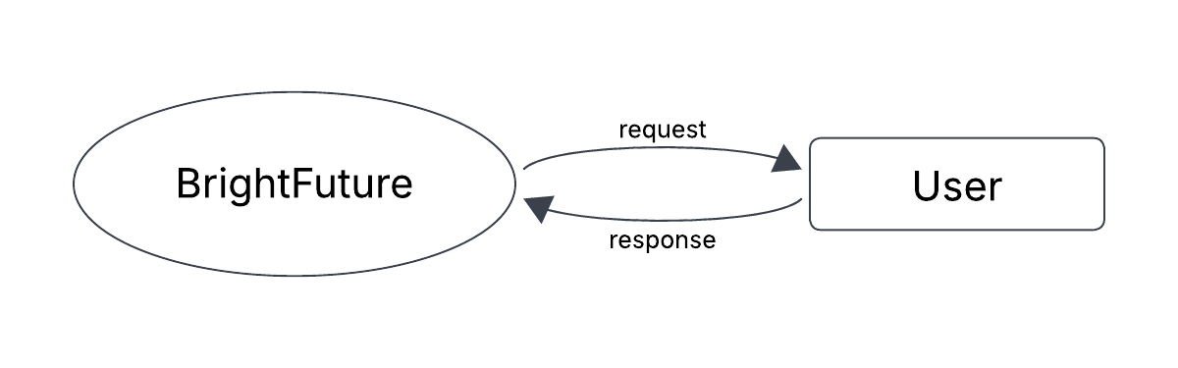Fig 3.2.1 DFD LEVEL 0 (Note-Taking App)

**LEVEL 1**

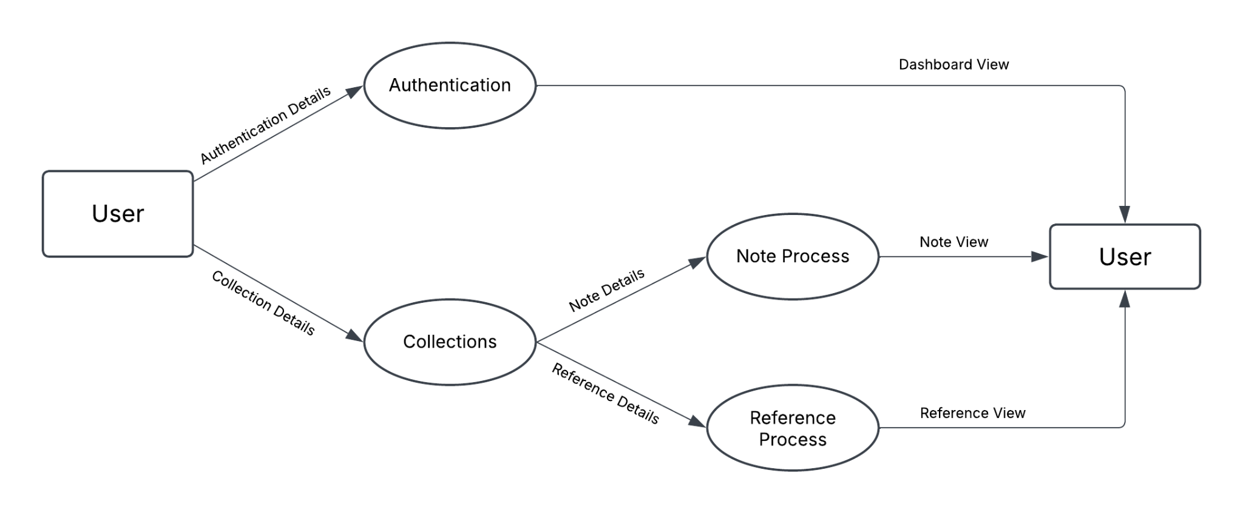

Fig 3.2.2 DFD LEVEL 1 (Note-Taking App)

**LEVEL 2**

LEVEL 2.1 REGISTRATION

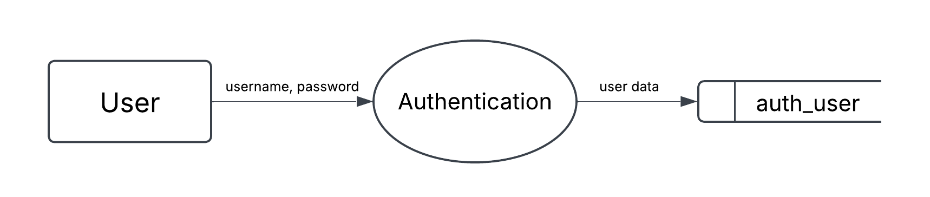

Fig 3.2.3 DFD LEVEL 2.1 (Registration Process)

LEVEL 2.2 CREATION

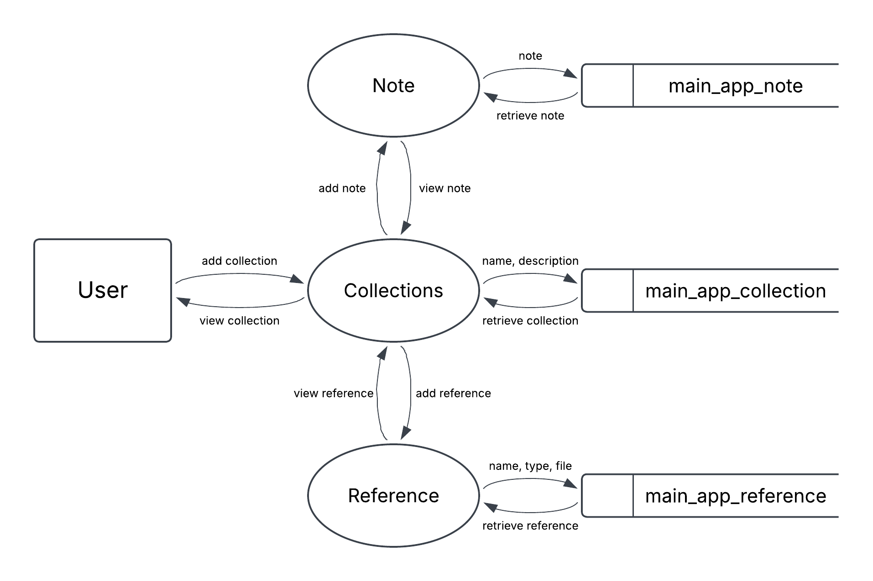

Fig 3.2.4 DFD LEVEL 2.2 (Creation Process)

LEVEL 2.3 EDITING

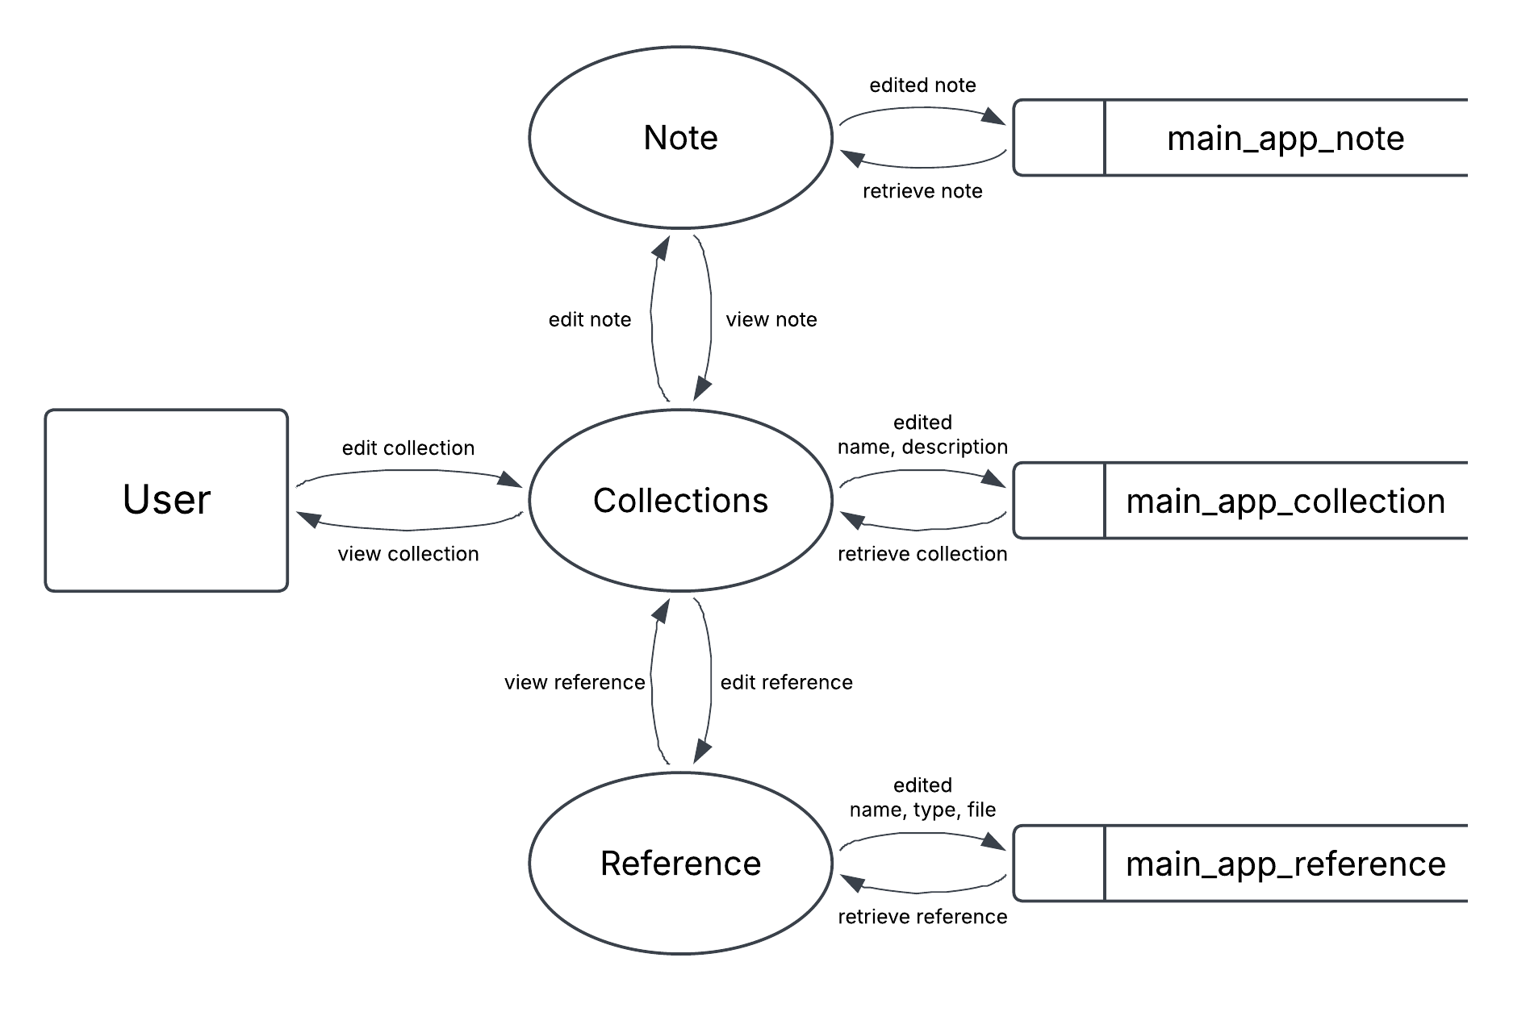

Fig 3.2.5 DFD LEVEL 2.3 (Editing Process)

LEVEL 2.4 DELETION

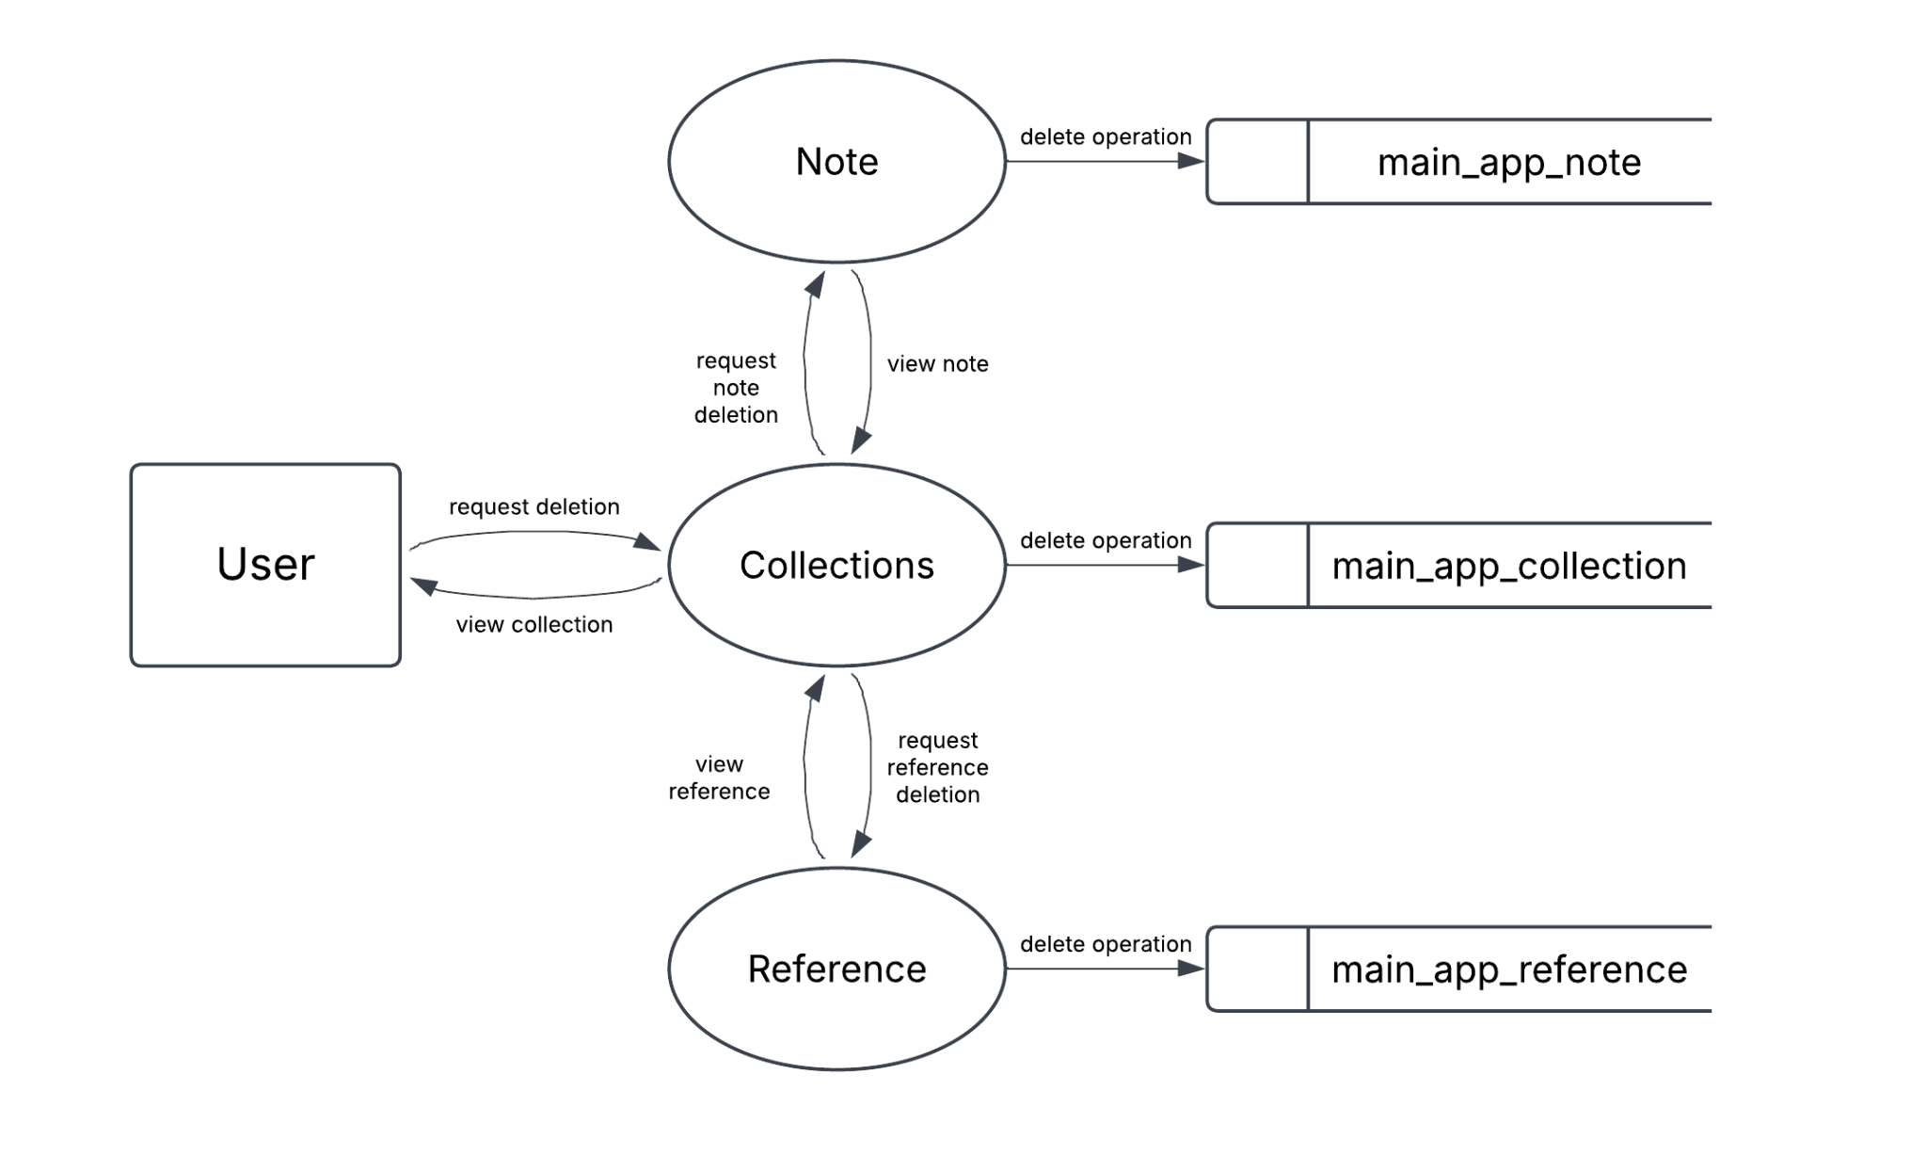

Fig 3.2.6 DFD LEVEL 2.4 (Deletion Process)

**3.3 WORKFLOW (MACHINE LEARNING MODEL)**

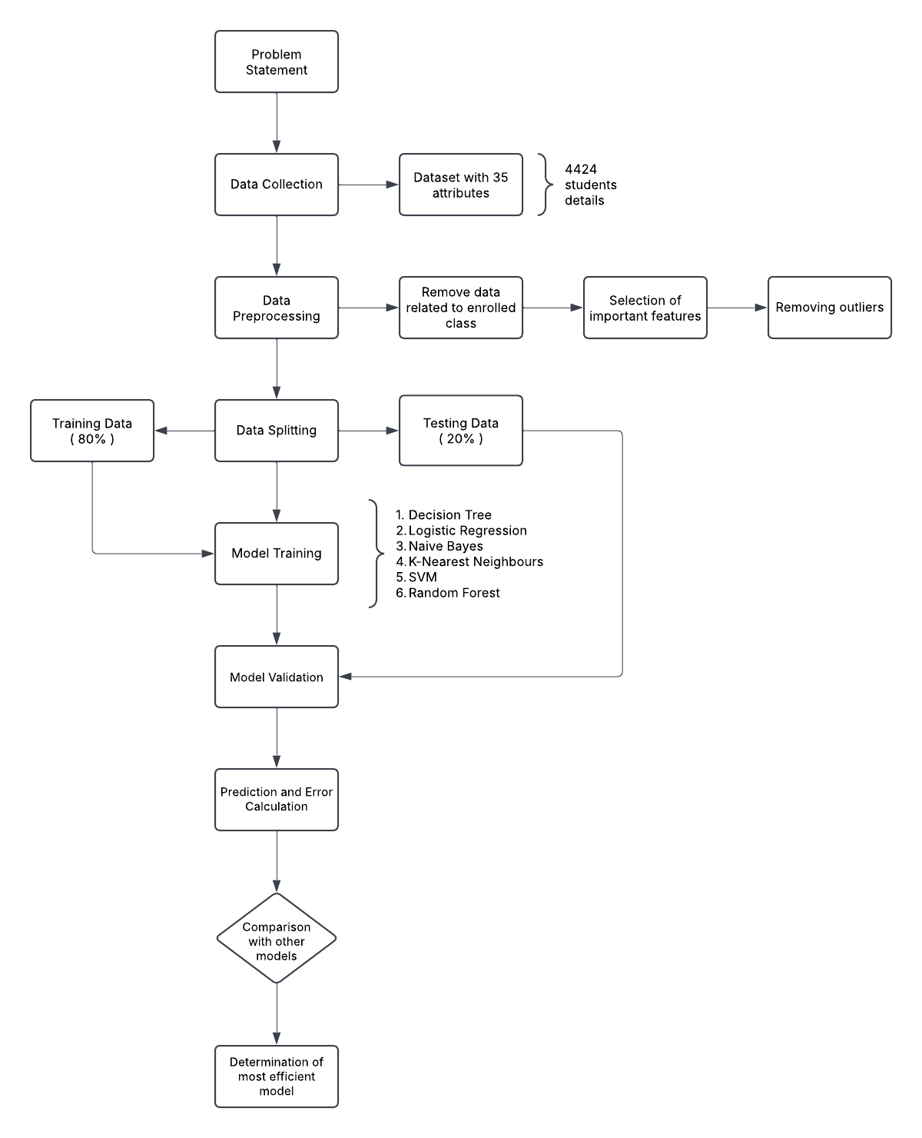

Fig 3.3 WORKFLOW (Prediction Model)

**3.4 WORKFLOW (RECOMMENDATION MODEL)**

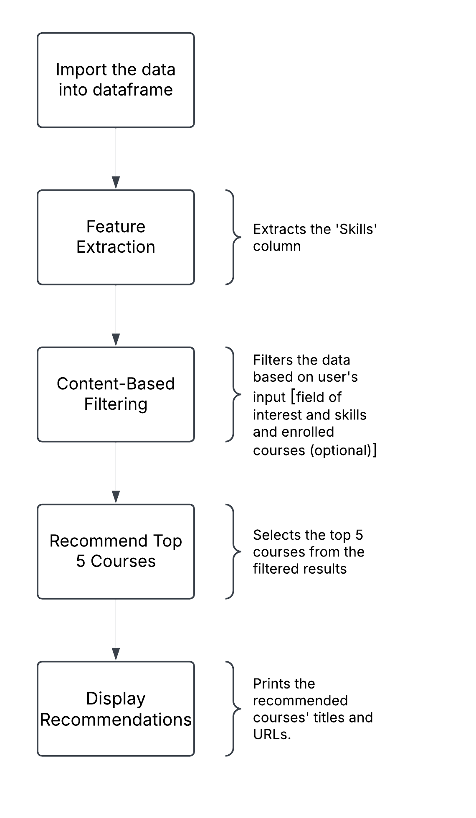

Fig 3.4 WORKFLOW (Recommendation Model)

**3.5 WORKFLOW (CONTACT FUNCTIONALITY)**

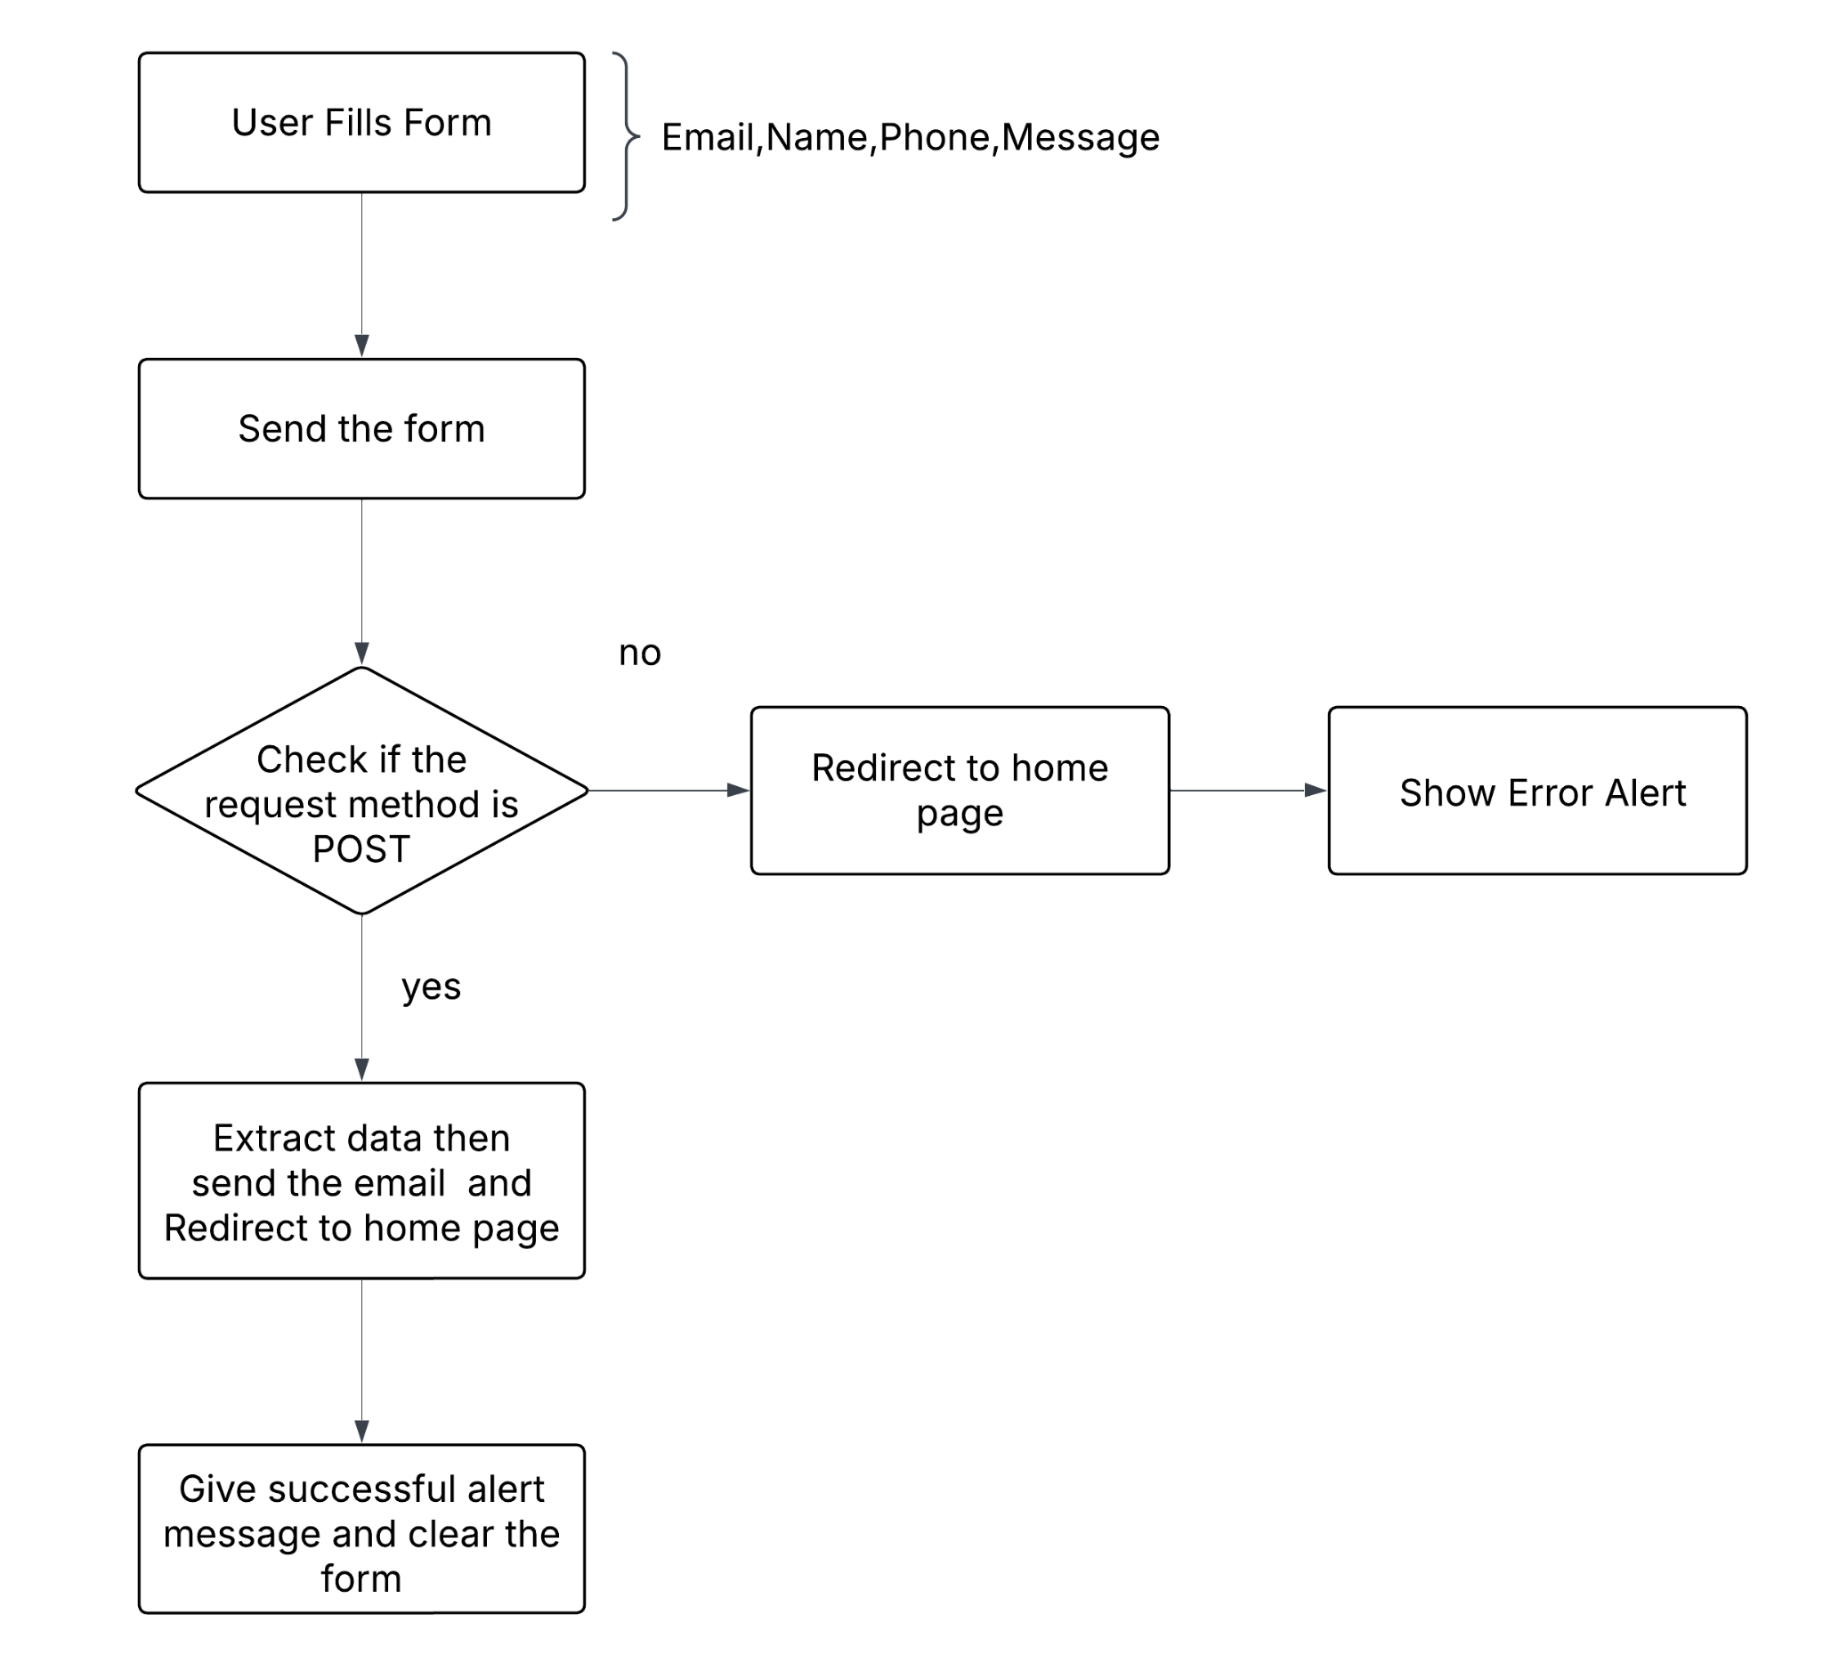

Fig 3.5 WORKFLOW (Contact Functionality)

**CHAPTER 4**

**IMPLEMENTATION & RESULT**

The BrightFuture project has successfully transitioned from conceptual design to a fully operational web application, marking a pivotal milestone in its deployment. The system, designed to integrate predictive analytics, personalized course recommendations, and a comprehensive note-taking application, has been developed to address critical student retention and academic success challenges.

The application’s architecture comprises a front-end built with HTML, CSS, and JavaScript, ensuring a responsive and user-friendly interface. The back-end leverages Python (Django) and PostgreSQL to manage data processing and storage, while AWS S3 provides secure and scalable multimedia storage. PGAdmin4 is used for managing the PostgreSQL database.

Students are granted immediate access to personalized course recommendations and dropout risk predictions without requiring login credentials. This functionality ensures that crucial support is readily available. The note-taking module, which necessitates user authentication, allows students to create, organize, and store notes, as well as upload various multimedia files, facilitating effective knowledge management.

**4.1 PREDICTION MODEL IMPLEMENTATION**

The dropout prediction system is a core component of BrightFuture, designed to proactively identify students at risk of academic attrition. By leveraging machine learning algorithms and analyzing key student data, including internal marks, attendance records, and tuition fee payment status, the system provides accurate predictions of potential dropout risks. The system's predictive capabilities are designed to be accessible to students without requiring login credentials, ensuring immediate and readily available support.

**4.1.1 DATASET & DATASET PREPROCESSING**

Selection of important classes

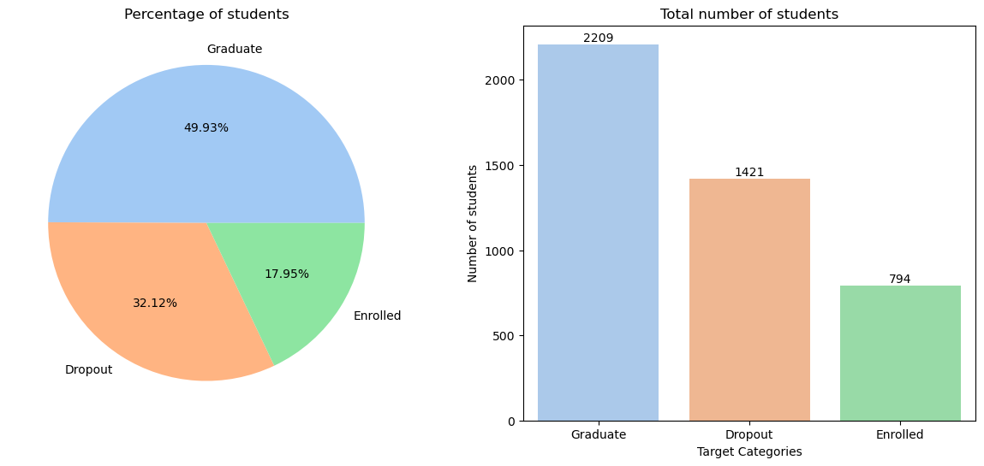

Fig 4.1.1.1 Selection of Important Classes

The number of graduating students is higher than the number of dropouts. The total number of graduating and dropout students is 2,209 + 1,421 = 3,630, the number of observations to build the models.

Therefore, remove all rows from the "Enrolled" class:

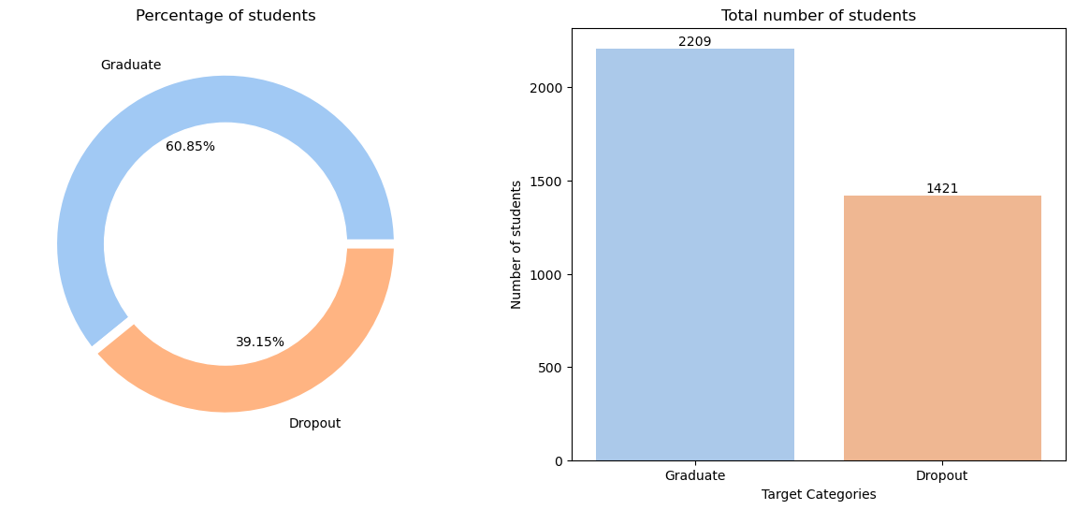

Fig 4.1.1.2 Removal of "Enrolled" class

**4.1.2 SELECT IMPORTANT FEATURES**

A correlation heatmap is a visual representation of the correlation between two or more variables. It is displayed in the form of a grid, where each cell represents the correlation between two variables. Colors in the heatmap are typically used to indicate the strength of the correlation, ranging from red (strong positive correlation) to blue (strong negative correlation).

The relation of all features to themselves:

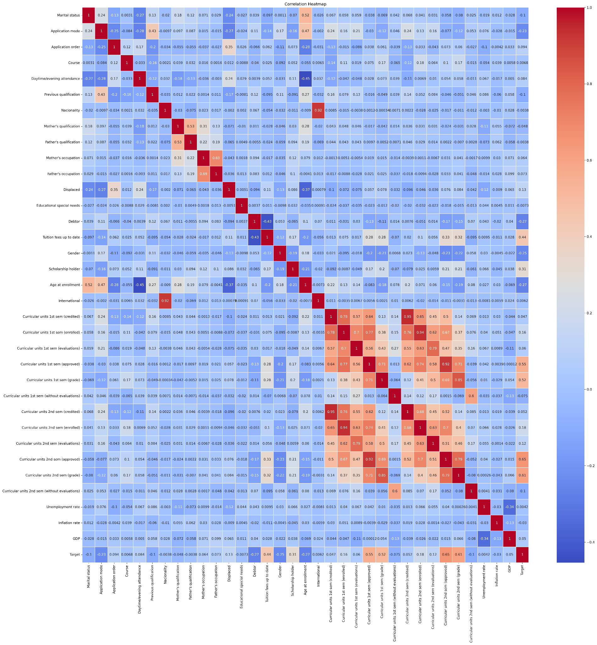

Fig 4.1.2.1 Correlation heatmap (with all features)

The correlation with all features with the target:

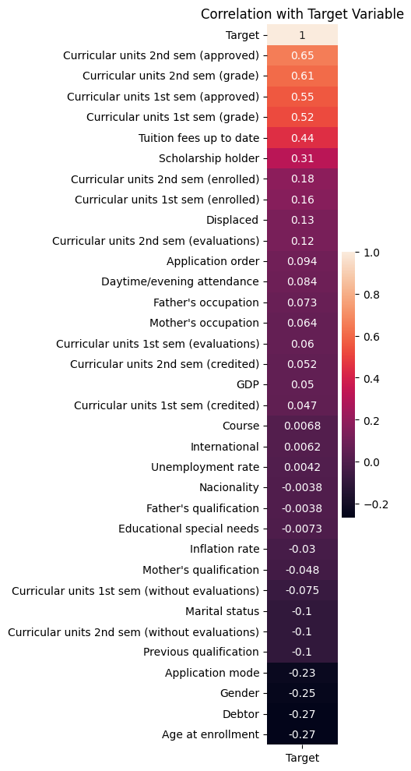

Fig 4.1.2.2 Correlation with all features with the target

Then we delete all features that have a negative correlation with the target and select only appropriate features needed for our project:

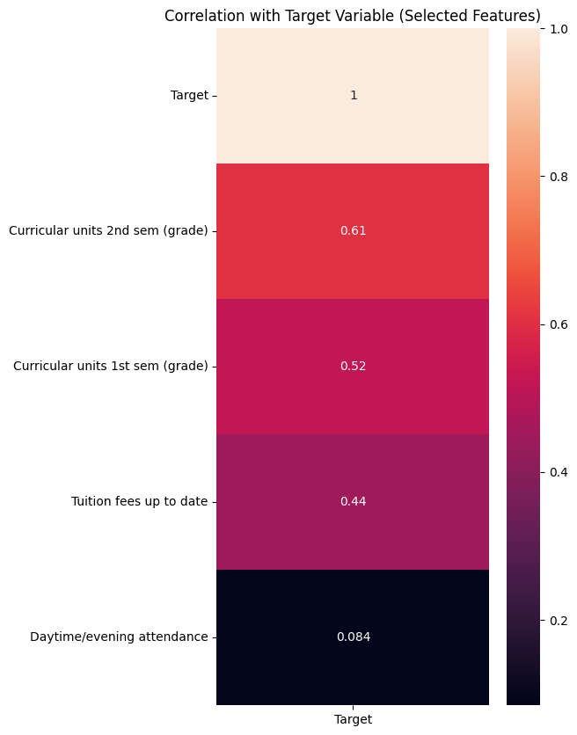

Fig 4.1.2.3 Correlation of 4 features with the target

**4.1.3 REMOVING OUTLIERS**

Outlier removal is a critical step in the data preprocessing phase. Outliers, also known as anomalies, are observations that deviate significantly from the general distribution of the data, potentially skewing statistical analyses. The presence of outliers can adversely affect the accuracy of predictive models and the validity of data-driven conclusions. However, given that our dataset has already undergone a filtering process, outlier removal is deemed unnecessary in this context.

**4.1.4 MODELS TRAINING**

1. Split Dataset:

We split the dataset into two parties: 80% for training and 20% for testing

1. Data Standardization:

The dataset was standardized using the StandardScaler method.

1. Grid Search:

The traditional way of performing hyperparameter optimization has been grid search, or a parameter sweep, which is simply an exhaustive search through a manually specified subset of the hyperparameter space of a learning algorithm. A grid search algorithm must be guided by some performance metric, typically measured by cross-validation on the training set or evaluation on a hold-out validation set.

1. Models Training:

We are going to use 6 popular classification algorithms to find the best solution for our problem: K-Nearest Neighbour, Naive Bayes, Decision Tree, Logistic Regression, Support Vector Machine (SVM) and finally, Random Forest Algorithm.

**K-NEAREST NEIGHBOUR (KNN):**

K-Nearest Neighbors (KNN) is a simple and intuitive machine learning algorithm used for classification and regression tasks. It assigns a new data point to the majority class of its k nearest neighbours in the feature space, where k is a user-defined parameter.

Here is the confusion matrix of K-Nearest Neighbors (KNN) illustrating model predictions.

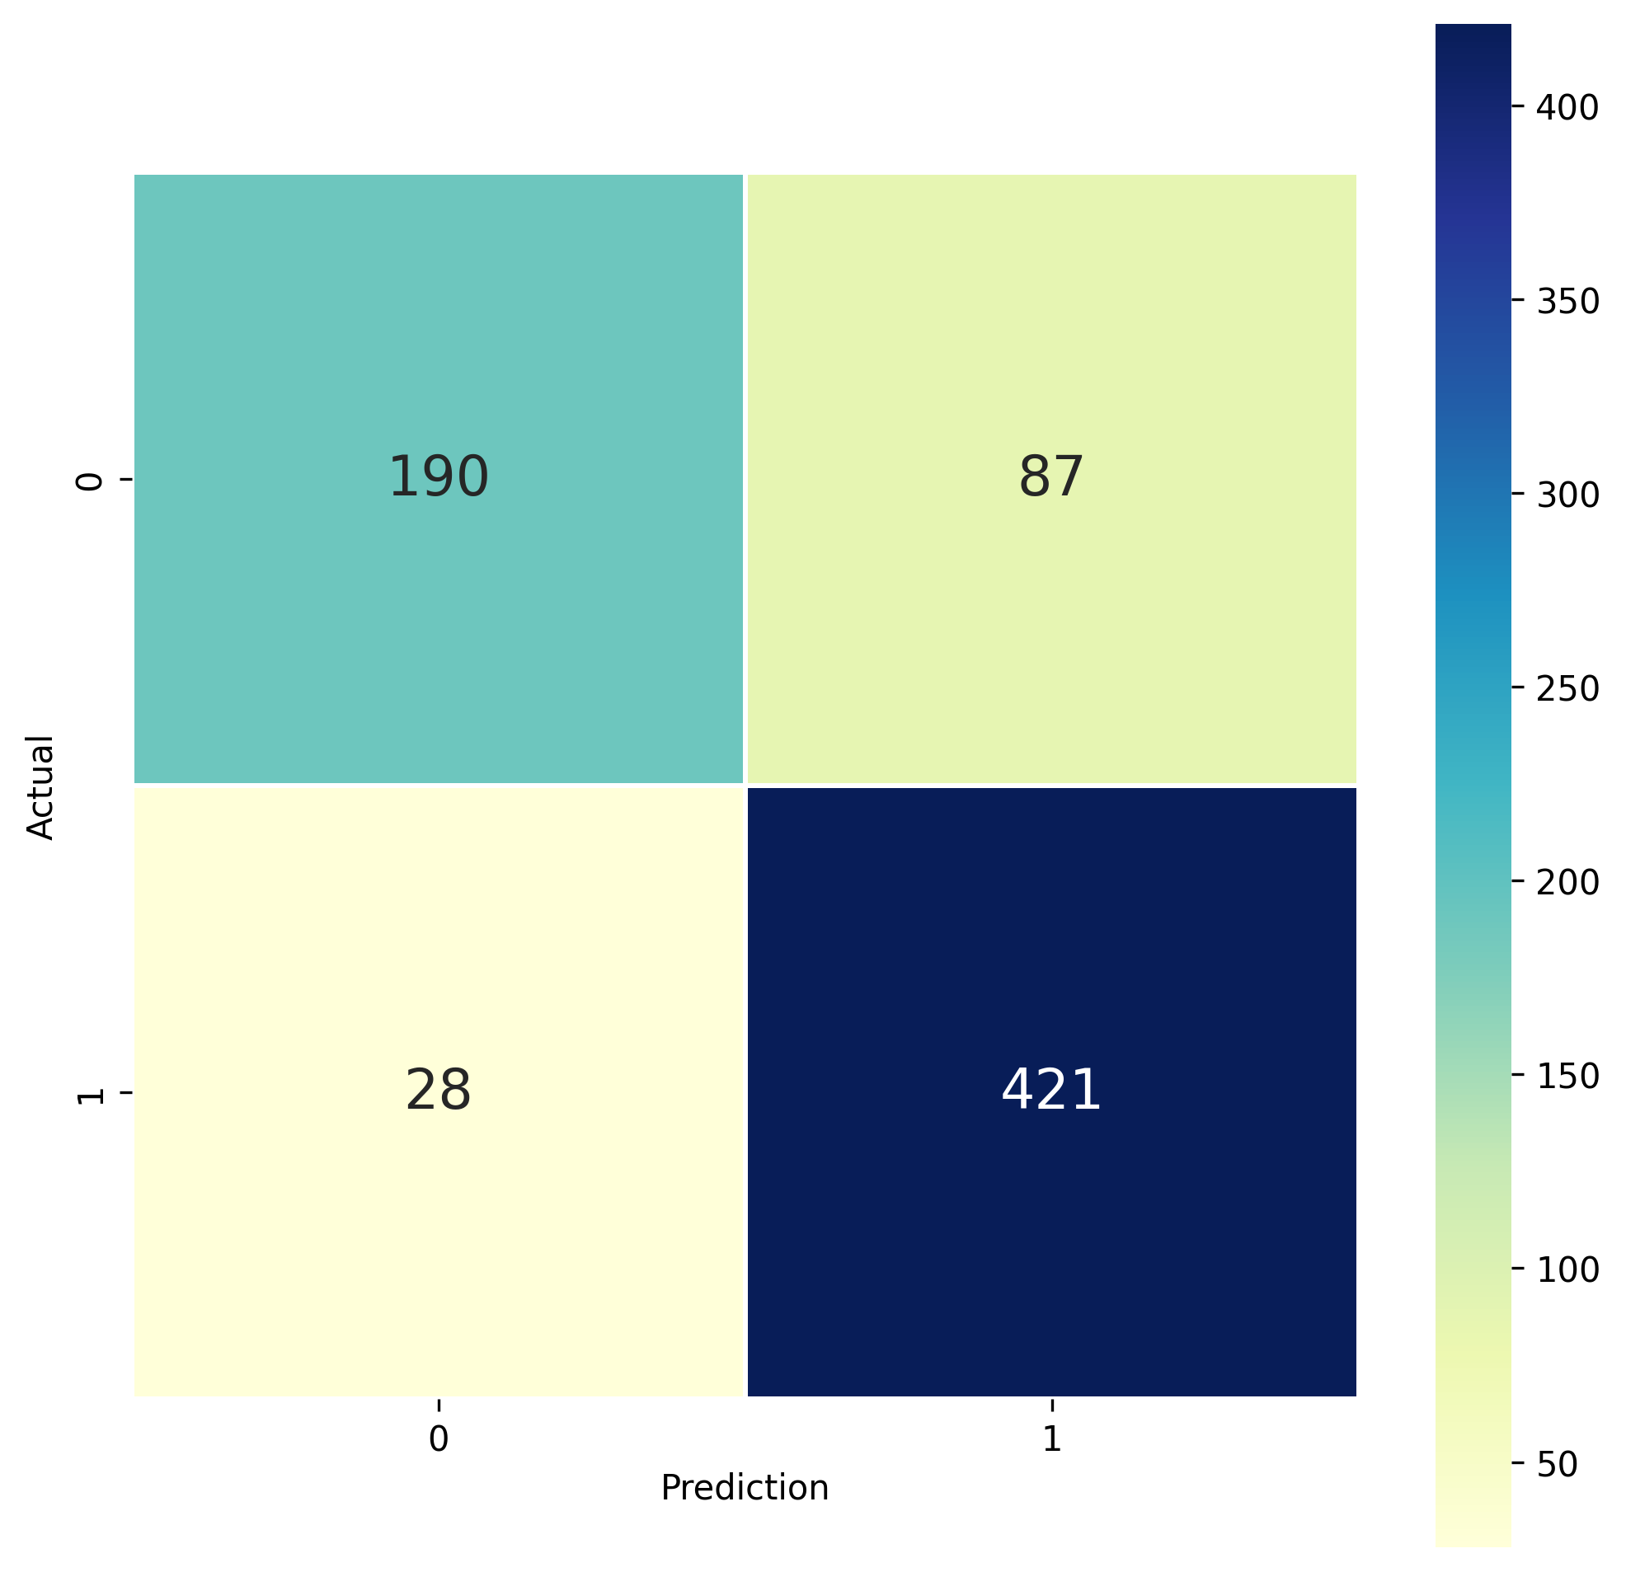

Fig 4.1.4.1: Confusion Matrix (K-Nearest Neighbors (KNN))

**LOGISTIC REGRESSION:**

Logistic Regression is a statistical method used for binary classification problems in machine learning. Despite its name, it's primarily employed for classification tasks. It models the probability that a given instance belongs to a particular category and makes predictions using a logistic function.

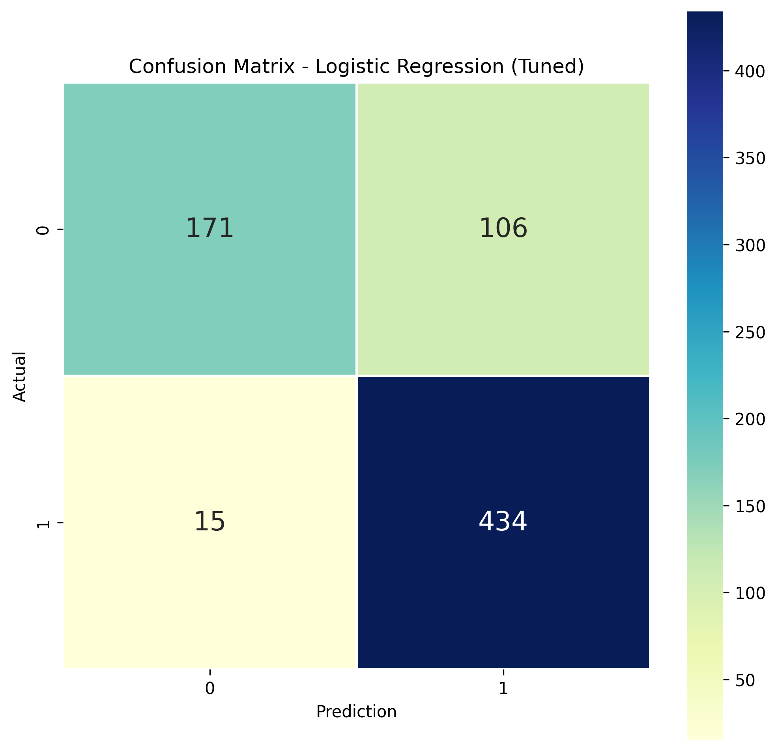

Fig 4.1.4.2: Confusion Matrix (Logistic Regression)

**DECISION TREE:**

Decision Tree is a versatile machine-learning algorithm used for both classification and regression tasks. It recursively splits the dataset based on the features, creating a tree-like structure where each internal node represents a decision based on a feature, and each leaf node represents the outcome. It's known for its interpretability and ability to handle both numerical and categorical data.

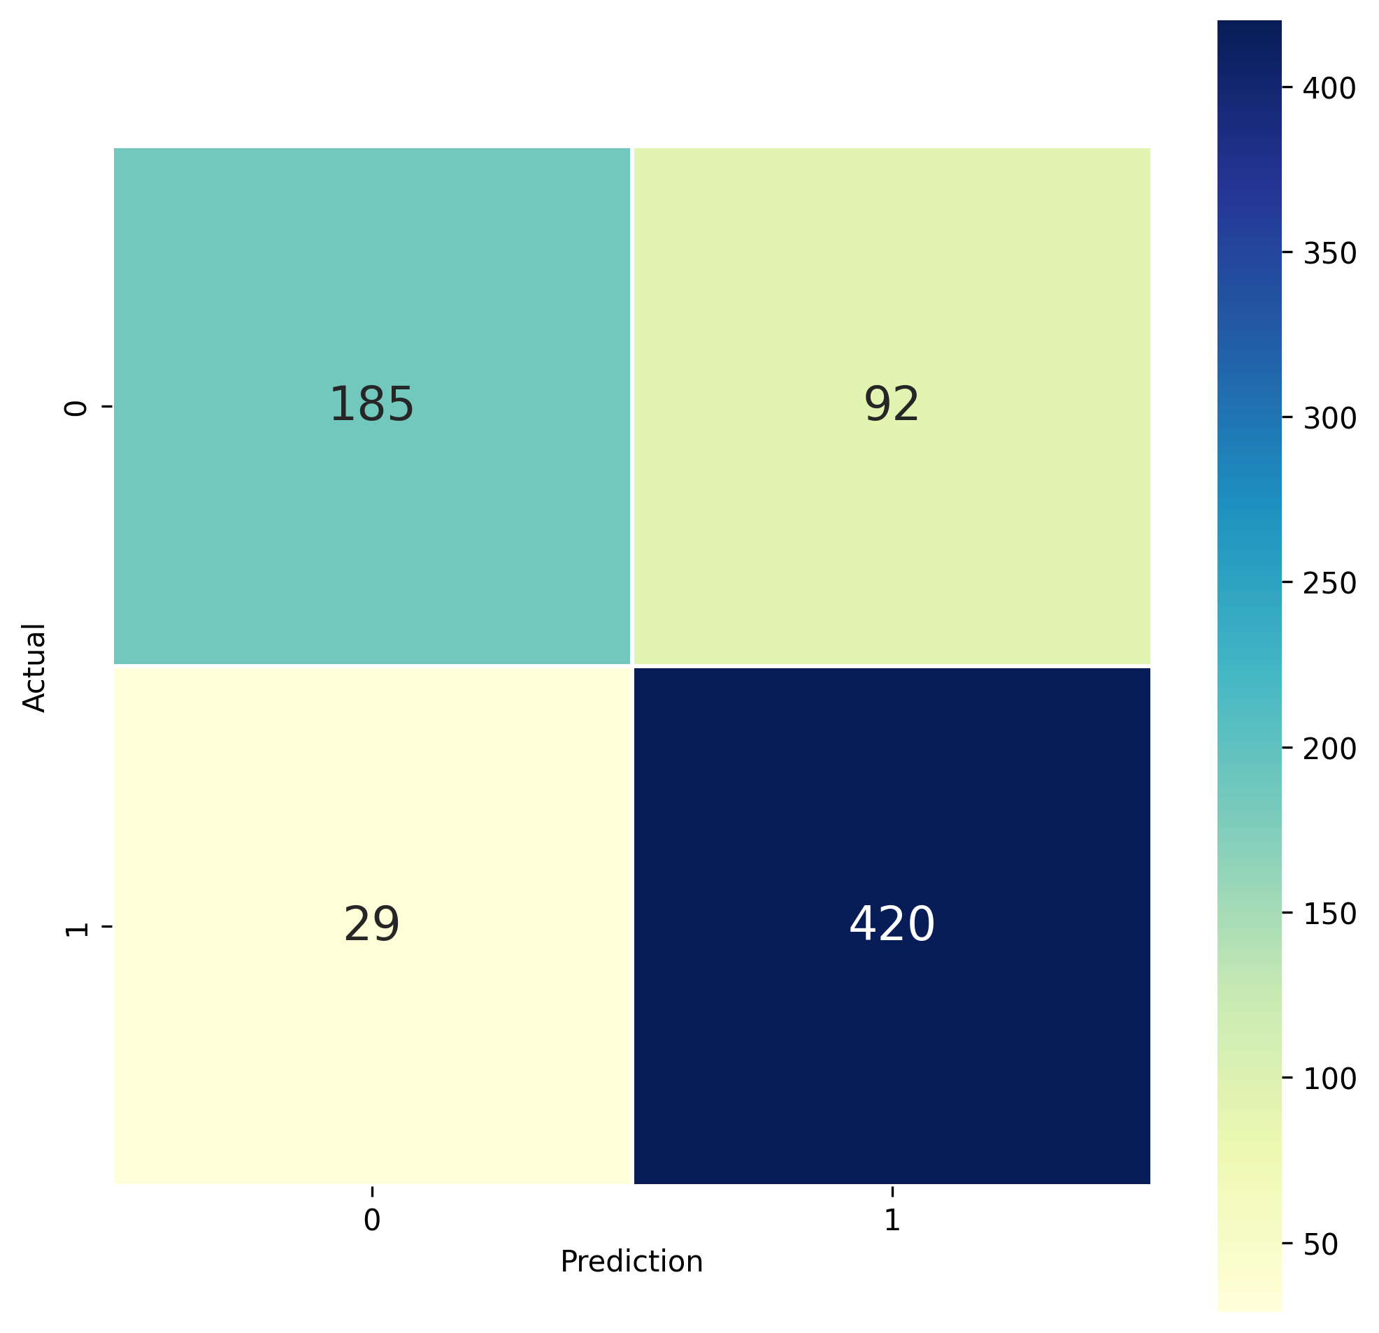

Fig 4.1.4.3: Confusion Matrix (Decision Tree)

**RANDOM FOREST:**

Random Forest enhances prediction accuracy and prevents overfitting by aggregating predictions from numerous randomly generated decision trees.

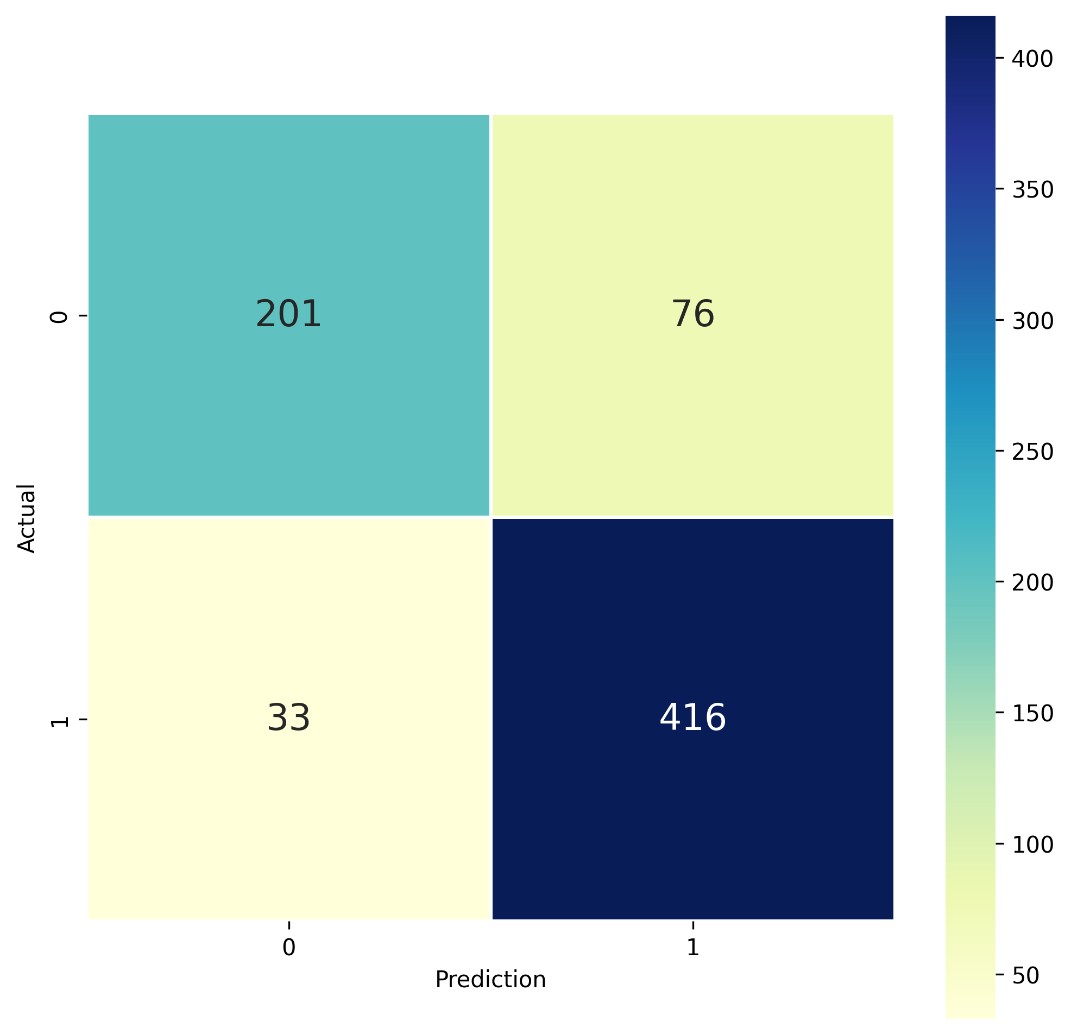

Fig 4.1.4.4: Confusion Matrix (Random Forest)

**SUPPORT VECTOR MACHINE (SVM):**

Support Vector Machine (SVM) is a powerful supervised machine learning algorithm used for classification and regression tasks. It works by finding the optimal hyperplane that separates different classes in the feature space while maximizing the margin between them. SVM is effective in high-dimensional spaces and is capable of handling both linear and non-linear relationships through the use of kernel functions. It is widely used for its versatility and ability to handle complex decision boundaries.

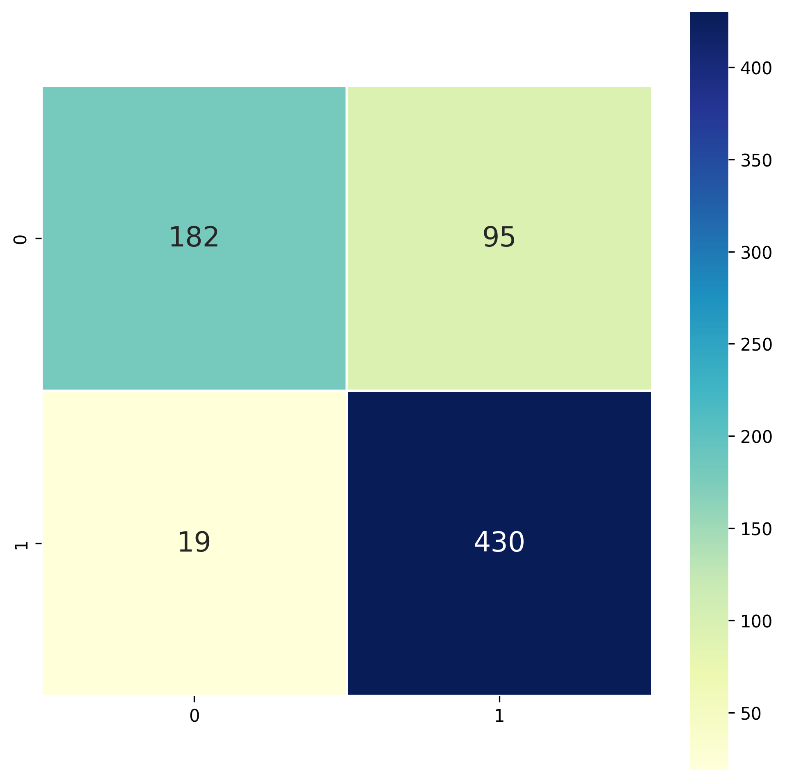

Fig 4.1.4.5: Confusion Matrix (SVM)

**NAIVE BAYES:**

Naive Bayes uses Bayes' theorem and feature independence to classify data. It's efficient and effective, especially for text analysis.

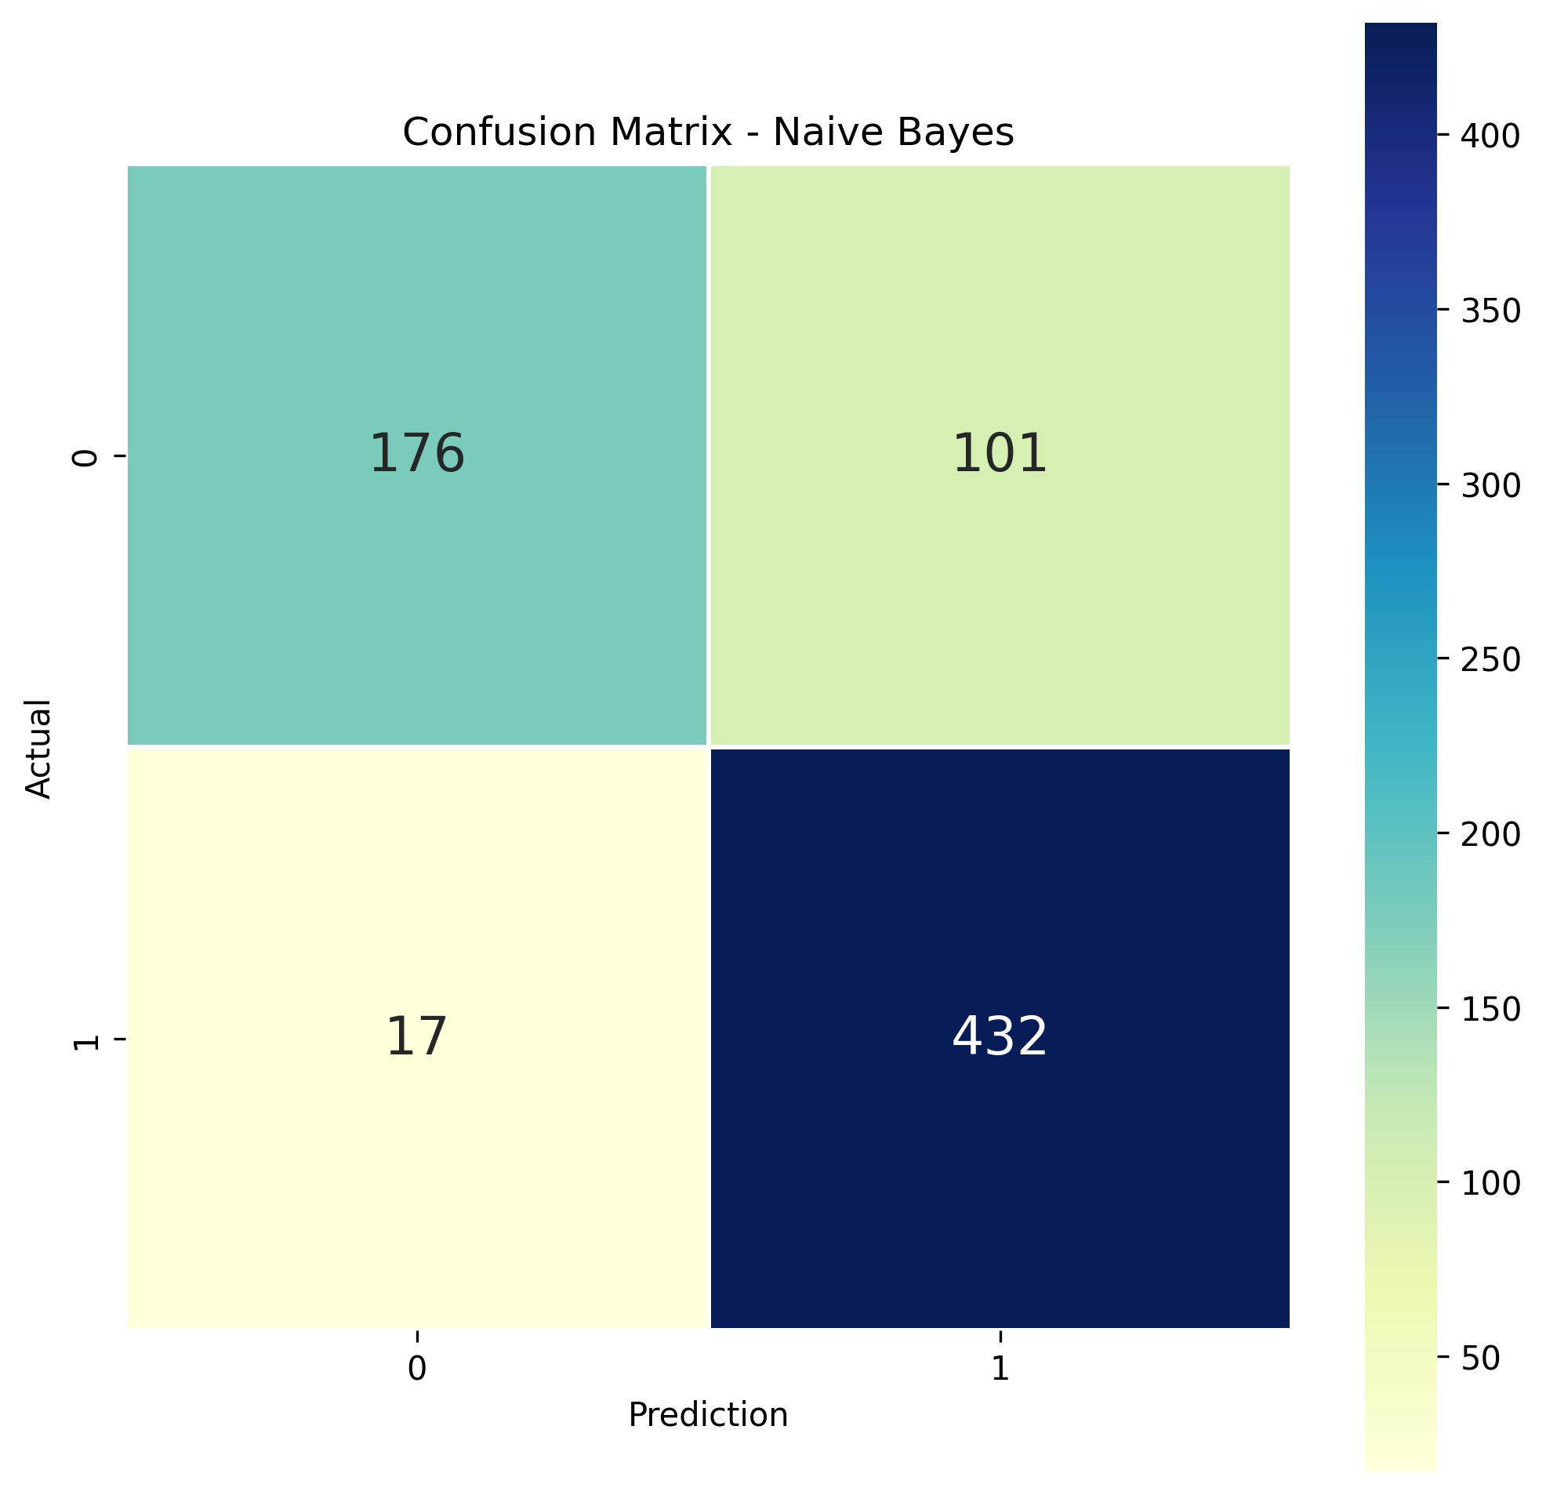

Fig 4.1.4.6: Confusion Matrix (Naive Bayes)

**4.1.5 MODELS RESULT**

The result of the 6 algorithms is:

|  |  |  |  |  |
| --- | --- | --- | --- | --- |
| **ALGORITHM** | **ACCURACY** | **PRECISION** | **RECALL** | **F1** |
| Random Forest | 0.851240 | 0.852259 | 0.851240 | 0.848297 |
| SVM | 0.842975 | 0.852022 | 0.842975 | 0.836618 |
| KNN | 0.841598 | 0.845078 | 0.841598 | 0.837040 |
| Naive Bayes | 0.847466 | 0.849199 | 0.837466 | 0.829893 |
| Logistic Regression | 0.833333 | 0.847830 | 0.833333 | 0.824622 |
| Decision Tree | 0.827824 | 0.833437 | 0.827824 | 0.821477 |

1. The Random Forest model has the best performance in terms of accuracy, precision, recall and F1-score.
2. Support Vector Machine (SVM) and K-Nearest Neighbor also have high performance.
3. Naive Bayes, Logistic Regression and Decision Tree have lower performance compared to other models.

Following a comprehensive evaluation of various models and their respective performance metrics, the Random Forest algorithm was selected as the optimal choice for the dropout prediction implementation.

**4.1.6 CONCLUSION**

The choice of the machine learning algorithm depends closely on the nature and specific requirements of the task at hand. There is no universal "best" algorithm, as each algorithm has its strengths and weaknesses. It is crucial to consider various factors such as the size and complexity of the data, the nature of the task, the availability of training data, and time and resource constraints.

**4.2 RECOMMENDATION SYSTEM IMPLEMENTATION**

The BrightFuture course recommendation system is designed to provide students with personalized course suggestions based on their interests, skills, and academic background. The system leverages content-based filtering to match student profiles with relevant online courses, primarily from the Coursera platform.

**4.2.1 DATA SOURCE AND PREPROCESSING**

* The system utilizes a CSV file (online_courses_data(Final).csv) as its primary data source. This file contains detailed information about online courses, including titles, URLs, categories, sub-categories, and required skills.
* The skills column in the CSV is preprocessed to handle missing values (NaNs) by replacing them with empty strings. This ensures that the system can accurately match skills even when the data is incomplete.

**4.2.2 CORE RECOMMENDATION FUNCTION AND USER INTERACTION**

The recommend_courses function is the core component of the recommendation system. It takes the following inputs:

* field_of_interest: The student's area of study or interest.
* skills: A list of the student's skills.
* enrolled_courses: A list of courses the student is currently enrolled in.

The function combines the student's interests and skills into search patterns. Regular expressions match these patterns against the course categories, sub-categories, and skills listed in the CSV file.

The system prompts the user to input their field of interest, skills (comma-separated), and optionally, enrolled courses (comma-separated).

The function selects the top 5 courses that match the student's profile and returns their titles and URLs. If no matching courses are found, a message is displayed indicating that no recommendations could be generated.

**4.2.3 TECHNOLOGY AND METHODOLOGY**

* The system is implemented in Python, leveraging the Pandas library for data manipulation and regular expressions for pattern matching.
* Content-based filtering is employed to match student profiles with relevant course content.
* The system focuses on recommending courses from the Coursera platform, as indicated by the URLs in the CSV file.

**4.2.4 RESULT**

Our Course Recommendation System is designed to help students find the most relevant online courses based on their field of interest, skills, and current enrollment. The system uses a content-based filtering algorithm to analyze course data and student profiles, ensuring personalized and accurate recommendations.

To build the course recommendation system, we used the following Python libraries:

* **Pandas:** For data manipulation and analysis of course information from the CSV file.
* **Regular Expressions (re):** For flexible pattern matching between student inputs and course data (categories, skills).

The recommendation system uses text-based matching and filtering to find the most relevant courses for a student. The steps are as follows:

* **Input Query:** The student provides their field of interest, skills (as comma-separated values), and optionally, currently enrolled courses.
* **Data Filtering:** The system filters the course dataset based on matches between the student's input and course categories, sub-categories, and skills.
* **Exclusion of Enrolled Courses:** If provided, the student's enrolled courses are removed from the recommendation list.
* **Top Recommendations:** The system selects the top 5 courses that match the student's profile, based on the filtered results.

After processing the student's input, the system provides a list of the top 5 recommended courses, including their titles and Coursera URLs.

Below is an example of the model's output:

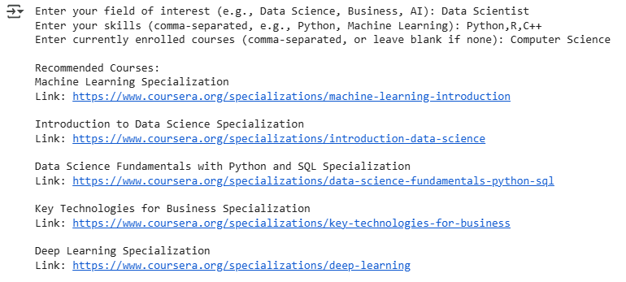

Fig 4.2.4 Model Output (Course Recommendation)

**4.2.5 CONCLUSION**

In conclusion, the BrightFuture course recommendation system effectively leverages content-based filtering to provide students with personalized course suggestions from the Coursera platform. While the current implementation relies on a static CSV file and text-based matching, it serves as a solid foundation for future enhancements, including real-time data integration and advanced semantic analysis.

**4.3 NOTE-TAKING APP IMPLEMENTATION**

The note-taking application within BrightFuture is designed to provide students with a robust and organized platform for managing their learning materials. It integrates seamlessly with the BrightFuture web application, offering a comprehensive solution for knowledge management.

**4.3.1 USER AUTHENTICATION AND ACCESS**

* Users are required to log in to access the note-taking application, ensuring secure and personalized storage of their data.
* This authentication requirement safeguards user privacy and ensures that only authorized individuals can access and modify their notes and collections.

**4.3.2 COLLECTION-BASED ORGANIZATION**

* The application employs a collection-based structure, allowing users to group related notes and references.
* A "Collection" serves as a container, enabling users to organize their study materials by subject, project, or any other relevant category.
* Users can create, edit, and delete collections, providing flexibility in managing their organizational structure.

**4.3.3 NOTE AND REFERENCE MANAGEMENT**

* Within each collection, users can create, edit, and delete individual notes.
* The application also supports the creation and management of references, which can include links, citations, or other external resources.
* This dual functionality allows students to integrate both their notes and external materials into a cohesive learning environment.

**4.3.4 MULTIMEDIA INTEGRATION AND STORAGE**

* The note-taking application supports the upload and storage of various multimedia files, including images, videos, and PDF documents.
* AWS S3 is utilized for the secure and scalable storage of these multimedia files, ensuring accessibility and reliability.
* This feature allows the users to have all the related data in one place.

**4.3.5 DATABASE STORAGE AND USER PROFILES**

* A database is employed to store text-based notes, user profiles, collection data, and reference data.
* This database ensures the persistence and integrity of user data, providing a reliable foundation for the application.

**4.3.6 TESTING**

Testing is a critical phase in software development to ensure the correctness, performance, and reliability of the system. This section provides an overview of the testing techniques applied to the note-taking app, which include unit testing, integration testing, validation testing, and black-box testing.

**UNIT TESTING**

Unit testing is the process of testing individual components or units of the software to ensure they work as expected.

|  |  |  |  |  |  |
| --- | --- | --- | --- | --- | --- |
| **Test Case ID** | **Test Case Description** | **Preconditions** | **Steps to Reproduce** | **Expected Results** | **Actual Results** |
| TC001 | Create a new note | The user is logged in | Navigate to the "New Note", enter note details, and click "Save" | The note is created successfully | Passed |
| TC002 | Edit an existing collection | The user has an existing collection | Navigate to the "Collection edit icon", modify collection details, and click "Submit" | The collection is updated successfully | Passed |
| TC003 | Delete a note | The user has an existing note | Navigate to the "Note List", select a note and click "Delete Note" | The note is deleted successfully | Passed |
| TC004 | Search for a collection | The user has multiple collections | Enter a keyword in the search bar and press "Search" | Collections matching the keyword displayed | Passed |

**INTEGRATION TESTING**

Integration testing aims to test the interaction between different modules of the system to ensure they work together correctly.

|  |  |  |  |  |  |
| --- | --- | --- | --- | --- | --- |
| **Test Case ID** | **Test Case Description** | **Preconditions** | **Steps to Reproduce** | **Expected Results** | **Actual Results** |
| TC001 | Sync notes with the database | The user has created notes | Create a note, then check the database for the saved note | The note is saved in the database | Passed |
| TC002 | View collections sorted by date | The user has multiple collections | Navigate to "My Collections" and select "Sort by Date Created" | Collections are sorted by creation date | Passed |
| TC003 | Share a collection with all other users | Collections should exist in the database | Navigate to “Collection details" and check the “share?” option. | The collection is shared successfully | Passed |
| TC004 | Retrieve notes linked to a user | The user has linked notes | Query the database for all notes linked to the user's profile | All linked notes retrieved | Passed |

**VALIDATION TESTING**

Validation testing ensures that the software meets the requirements and expectations of the end users. This testing involved checking the system's overall performance, security, and usability.

|  |  |  |  |  |  |
| --- | --- | --- | --- | --- | --- |
| **Test Case ID** | **Test Case Description** | **Preconditions** | **Steps to Reproduce** | **Expected Results** | **Actual Results** |
| TC001 | Create a note with missing fields | The user is on the Create Note Section page | Leave the required fields empty and click "Submit" | Error message displayed | Passed |
| TC002 | Register with an existing username | Username already exists | Enter the existing username and sign up | Error message displayed | Passed |
| TC003 | Login with invalid credentials | The user has invalid credentials | Enter incorrect credentials, click login | Error message displayed | Passed |

**BLACKBOX TESTING**

Black-box testing evaluates the functionality of the system by testing its inputs and outputs without looking into the internal code. This type of testing ensures that all user-facing features work as intended, providing a reliable and intuitive experience for the end users.

|  |  |  |  |  |  |
| --- | --- | --- | --- | --- | --- |
| **Test Case ID** | **Test Case Description** | **Preconditions** | **Steps to Reproduce** | **Expected Results** | **Actual Results** |
| TC001 | Navigate through the app's main sections | The user is logged in | Click on different main menu links (e.g., "Notes List", "Create Note") | Correct page loaded for each menu link | Passed |
| TC002 | Add a reference to a collection | The user is logged in | Create a new reference and assign it to a specific collection | The reference is added to the collection | Passed |
| TC003 | Add a note to a collection | The user is logged in | Create notes and assign them to the collection | The note is added to the collection | Passed |
| TC004 | Validate minimum length and check if the password is entirely numeric | The user is filling out the sign-up form | Enter invalid password pattern (in entire number & less than 8 characters) | Error messages displayed | Passed |

**4.3.7 CONCLUSION**

The implementation of the BrightFuture note-taking application successfully delivers a personalized and organized learning environment for students. Through the use of collections, multimedia support, and intuitive interfaces, students can efficiently manage their notes and references. The application's focus on user authentication and secure storage ensures data privacy and reliability, laying a strong foundation for future collaborative and integrative functionalities.

**4.4 CONTACT FUNCTIONALITY IMPLEMENTATION**

The BrightFuture contact functionality is designed to enable users to communicate with the development team directly via email through a user-friendly contact form. This feature facilitates user inquiries, feedback, and support requests.

**4.4.1 FORM IMPLEMENTATION AND USER INTERACTION**

The contact form is implemented using HTML and Django's form-handling capabilities. Users are presented with fields for their name, email address, subject, and message. Upon submission, the form data is processed by the Django backend. The system validates the user input, ensuring that all required fields are filled and that the email address is in a valid format. The user is notified upon successful submission of the form.

**4.4.2 EMAIL PROCESSING AND DELIVERY**

The Django backend utilizes its built-in email functionality to send the contact form data to the development team's designated email address. The email is sent using Gmail's SMTP server, configured with the necessary credentials and settings. The system is configured to send emails via Gmail's SMTP server. The EMAIL_HOST_USER and EMAIL_HOST_PASSWORD settings provide the credentials for the sending email account. When a user submits the contact form, the form data is processed by the Django backend, and an email is sent to the CONTACT_EMAIL address. The DEFAULT_FROM_EMAIL is set to the same address as the sender. The EMAIL_PORT and EMAIL_USE_TLS settings ensure a secure connection to the SMTP server. The email backend used is 'django.core.mail.backends.smtp.EmailBackend'.

**4.4.3 TECHNOLOGY AND METHODOLOGY**

The contact functionality is implemented using Django's form handling and email capabilities. The system uses Gmail's SMTP server for email delivery. HTML is used for the contact form's front-end structure. Python is used for the backend logic.

**4.4.4 RESULT AND DISCUSSION**

The contact functionality provides a straightforward and reliable method for users to communicate with the development team. The use of Django's built-in email features simplifies the implementation and ensures compatibility with the existing backend architecture. The use of Gmail's SMTP server offers a robust and widely supported email delivery mechanism. The system successfully sends the email.

**4.4.5 CONCLUSION**

The contact functionality in BrightFuture provides a valuable communication channel for users, enabling them to easily reach the development team. The use of Django's email capabilities and Gmail's SMTP server ensures reliable and efficient email delivery. Future enhancements could include adding features like automated response confirmation or integration with a ticketing system for more structured support management.

**CHAPTER 5**

**CONCLUSION**

In conclusion, BrightFuture represents a significant step forward in leveraging technology to enhance student success and institutional effectiveness. This comprehensive platform is designed to address critical challenges in higher education, including student attrition, personalized learning, and effective knowledge management. By integrating advanced features, BrightFuture aims to transform the way educational institutions support their students.

**5.1 ADVANTAGES**

* **Predictive Dropout Analysis:** Enables proactive intervention by identifying students at risk of dropping out.
* **Course Recommendations:** Guides students towards relevant academic pathways, improving engagement and academic success.
* **Integrated Multimedia Note-Taking:** Provides a versatile tool for organizing and managing learning materials, enhancing knowledge retention.
* **Accessible Predictive and Recommendation Services:** Students can access personalized course recommendations and dropout predictions without logging in.
* **Direct Communication Channel:** Integrates a contact functionality, enabling users to easily reach the development team for inquiries, feedback, and assistance.

**5.2 LIMITATIONS**

Despite its numerous benefits, BrightFuture has some limitations. The accuracy of the predictive models relies heavily on the quality and completeness of student data. Implementing and maintaining the note-taking application requires ongoing technical support and user training. The course recommendation system, while effective, is currently limited to Coursera courses and relies on text-based matching. Additionally,

ensuring data privacy and security is paramount, requiring robust security measures and compliance with data protection regulations.

**5.3 FUTURE SCOPE**

Looking ahead, BrightFuture holds significant potential for further enhancement and expansion. Future developments could include:

* **Advanced Predictive Modeling:** Integrating more sophisticated machine learning algorithms and expanding data sources to improve prediction accuracy.
* **Expanded Course Integration:** Incorporating courses from a wider range of platforms and institutions, and implementing semantic matching for more accurate recommendations.
* **Collaborative Learning Features:** Adding features for collaborative note-taking and study groups within the note-taking application.
* **Real-Time Data Integration:** Integrating with institutional systems for real-time updates on student progress and attendance.
* **Personalized Learning Pathways:** Developing personalized learning pathways based on student performance and interests.
* **Mobile Application:** Creating a mobile application to increase accessibility for students.
* **AI-Powered Learning Assistance:** Implementing AI-powered learning assistance, such as chatbots or virtual tutors, to provide on-demand support.
* **Feedback and Analytics Dashboard:** Develop a dashboard to provide students with feedback on their learning habits and progress.
* **Enhanced Communication Features:** Expanding the contact functionality to include features like a ticketing system, FAQs, or a knowledge base to provide more comprehensive user support.

By addressing these areas, BrightFuture can continue to advance educational support systems, providing even greater efficiency and support for students and institutions.

**REFERENCES**

[1] A. Hussain, S. Zhu, W. Zhang, and S. Abedin, "Predicting Student Academic Performance Using Ensemble Methods," *IEEE Access*, vol. 7, pp. 135245-135256, 2019.

[2] Y. Kim, H. Lee, and J. Park, "Deep Learning-Based Student Performance Prediction Using Multi-Modal Educational Data," in *2020 International Conference on Information and Communication Technology Convergence (ICTC)*, Jeju Island, Korea (South), 2020, pp. 156-159.

[3] M. Khalil, M. Ebner, and M. Kopp, "Learning Analytics Dashboards: A Systematic Review," in *2018 IEEE Global Engineering Education Conference (EDUCON)*, Santa Cruz de Tenerife, Spain, 2018, pp. 1095-1102.

[4] S. Crossley, D. S. McNamara, and P. Allen, "Using natural language processing to predict student engagement from online forum posts," *IEEE Transactions on Learning Technologies*, vol. 12, no. 1, pp. 88-100, 2019.

[5] R. Nkambou, J. Bouchard, and G. Psaromiligkos, "Intelligent Tutoring Systems: A Survey and Roadmap," *Information and Software Technology*, vol. 115, pp. 66-82, 2019.

[6] G. Holmes, "Ethical considerations in the use of learning analytics in higher education," *Educational Technology Research and Development*, vol. 68, no. 5, pp. 1957-1979, 2020.

[7] A. Kukulska-Hulme, U. Cress, and A. B. Chhokar, "Mobile learning for quality education and social inclusion," *Distance Education*, vol. 37, no. 2, pp. 244-259, 2016.

[8] R. Fryer, B. Ainley, and J. Thompson, "Chatbots in education: a review of the literature," in *EdMedia + Innovate Learning*, 2019, pp. 780-788.

[9] M. Ifenthaler, D. Shum, and X. Y. Yau, *Learning analytics: From research to practice*, Routledge, 2016.

**APPENDIX**

**SCREENSHOT**

**1. HOMEPAGE**



